**BIOMETRIC VOTING SYSTEM**

By

Grant T Tsikisayi

H190306z

HIT400 Capstone project Submitted in Partial Fulfillment of the

Requirements of the degree of

Bachelor of Technology

In

**Software Engineering**

In the

**School of Information Sciences and Technology**

Harare Institute of Technology

Zimbabwe



Mrs Zindove

May/2023

|  |  |  |
| --- | --- | --- |
| **ITEM** | **TOTAL MARK /%** | **ACQUIRED/%** |
| **PRESENTATION-**  Format-Times Roman 12 for ordinary text, Main headings Times Roman 14, spacing 1.5. Chapters and sub-chapters, tables and diagrams should be numbered. Document should be in report form. Range of document pages. Between 50 and 100.Work should be clear and neat | **5** |  |
| **Pre-Chapter Section**  Abstract, Preface, Acknowledgements, Dedication & Declaration | **5** |  |
| **Chapter One-Introduction**  Background, Problem Statement, Objectives – smart, clearly measurable from your system. Always start with a TO…  Hypothesis, Justification, Proposed Tools  Feasibility study: Technical, Economic & Operational  Project plan –Time plan, Gantt chart | **10** |  |
| **Chapter Two-Literature Review**  Introduction, Related work & Conclusion | **10** |  |
| **Chapter Three –Analysis**  Information Gathering Tools, Description of system  Data analysis –Using UML context diagrams, DFD of existing system  Evaluation of Alternatives Systems, Functional Analysis of Proposed System-Functional and Non-functional Requirements, User Case Diagrams | **15** |  |
| **Chapter Four –Design**  Systems Diagrams –Using UML Context diagrams, DFD, Activity diagrams  Architectural Design-hardware, networking  Database Design –ER diagrams, Normalized Databases  Program Design-Class diagrams, Sequence diagrams, Package diagrams, Pseudo code  Interface Design-Screenshots of user interface | **20** |  |
| **Chapter Five-Implementation & Testing**  Pseudo code of major modules /Sample of real code can be written here  Software Testing-Unit, Module, Integration, System, Database & Acceptance | **20** |  |
| **Chapter Six –Conclusions and Recommendations**  Results and summary, Recommendations & Future Works | **10** |  |
| **Bibliography –Proper numbering should be used**  Appendices –templates of data collection tools, user manual of the working system, sample code, research papers | **5** |  |
|  | **100** | **/100** |

**HIT 400 /200 Project Documentation Marking Guide**

# Certificate of Declaration

This is to certify that work entitled “HIT400 Research Topic “ *is submitted in partial fulfillment of the requirements for the award of Bachelor of Technology (Hons) in Software Engineering ,Harare Institute of Technology .It is further certified that no part of research has been submitted to any university for the award of any other degree .*



(Supervisor) Signature…………………………….. Date……………………….

(Mentor ) Signature…………………………….. Date………………………

(Chairman) Signature……………………………….. Date………………………..

# **Abstract**

Voting enables citizens to express their opinions and participate in the creation of a democratic government; therefore, the procedure should be trustworthy, accurate, and transparent. A voter's vote cannot be counted in the majority of countries unless they cast a paper ballot and place it in a voting box. Most people claim to have participated in numerous manipulated elections. To solve these issues, I suggest using fingerprints as a form of electronic voter identification. Voting machines will be used by registered voters to cast their ballots. The suggested model allows for the use of fingerprints to count votes. The voting device will be connected to the system via IOT technology. The technique employs fingerprints to uniquely identify voters because each person's fingerprints have a unique pattern. As a result, it would be preferable to the current voting procedures. During an election, a voter's fingerprint is entered into the system. Then, this is compared to the records that are already in the database. If the precise pattern matches anyone in the database, voting rights are granted. However, if the pattern does not match the database records or if there is recurrence, authorization to vote is denied or the vote is disregarded. A network that connects each and every voting machine transmits data to the main host. The result is immediate, and the primary host is used for the final tally. Election-related expenses as a whole drop, as does the cost of keeping the systems running. This concept is proposed by considering the current electoral procedure norms. Therefore, migrating to this system can be very easy.

# **Preface**

This report presents the design and implementation of a biometric voting system. The system is designed to provide a secure and reliable way to conduct elections. The system uses biometric technology to verify the identity of voters and prevent fraud. The system is designed to be user-friendly and efficient.

The report is divided into several sections. The first section provides an introduction to the biometric voting system and its benefits. The third section describes the system architecture and its components. The fourth section discusses the design features of the system. The fifth section provides details on the implementation of the system. Finally, the last section presents the results of the testing and evaluation of the system.

# **Acknowledgements**

I would like to express my sincere gratitude to my supervisor for her guidance and support throughout the development of this project. I would also like to thank the staff at the library for their assistance in providing me with the necessary resources. Finally, I would like to thank all the participants who took part in this study.

# **Dedication**

This project is dedicated to my family, who have always been my inspiration and motivation. Their unwavering support and encouragement have been instrumental in my success. I would also like to dedicate this project to my friends and colleagues who have provided me with valuable insights and feedback throughout the development process. Without their help, this project would not have been possible.

**Table of Contents**

Contents

Certificate of Declaration 3

**Abstract** 4

**Preface** 5

**Acknowledgements** 6

**Dedication** 7

1 Chapter 1 Introduction 11

1.1 Background 11

1.2 Problem Statement 11

1.3 Objectives 11

1.4 Hypothesis 12

1.5 Justification 12

1.6 Proposed Tools 12

1.7 Feasibility Study 13

1.7.1 Technical 13

1.7.2 Economic 13

1.7.3 Operational Feasibility 14

1.8 Project Plan 14

1.8.1 Time Plan 14

1.8.2 Gantt chart 15

2 Chapter 2 Literature Review 16

2.1 Introduction 16

2.2 Alternate Systems 16

2.3 Conclusion 18

3 Chapter 3 Analysis 19

3.1 Information gathering tools 19

3.1.1 Observation 19

3.1.2 Questionnaire 20

3.1.3 Interviews 21

3.2 Description of existing system 22

3.3 Data Analysis 23

3.3.1 UML Context Diagram 23

3.3.2 Data Flow Diagram 23

3.4 Evaluation of Alternative Systems 24

3.4.1 Functional and Non-Functional Requirements 24

3.4.2 Use Case Diagram 25

4 Chapter 4 Design 26

4.1 Systems Diagrams 26

4.1.1 Context Diagram 26

4.1.2 DataFlow Diagram 27

4.1.3 Activity Diagram 28

4.2 Architectural Design 30

4.2.1 Hardware (Voting Device) 30

4.2.2 Networking 30

4.3 Database Design 31

4.3.1 Entity Relationship Diagram 31

4.3.2 Normalized Databases 32

4.4 Program Design 34

4.4.1 Class Diagram 34

4.4.2 Sequence Diagram 34

4.5 User Interface Design 37

4.5.1 Log In 37

4.5.2 Registration 37

4.5.3 Voter’s Profile 38

4.5.4 Results 38

4.5.5 Voter’s Roll 39

4.5.6 Reports 39

5 Chapter 5 Implementation and testing 40

5.1 Pseudocode 40

5.1.1 Voting 40

5.1.2 Registration 51

5.2 System Testing 61

5.2.1 Unit Testing 61

5.2.2 Integration Testing 62

5.2.3 System Testing 63

5.2.4 Database Testing 63

5.2.5 Acceptance Testing 64

5.3 Installation and Deployment 65

5.3.1 Setting up the System 65

5.4 Maintenance 65

6 Chapter 6 66

6.1 Results 66

6.1.1 Successful Registration 66

6.1.2 Successful Voting 66

6.1.3 Validation 66

6.2 Summary 68

6.3 Reccomendations 69

6.4 Future works 70

6.5 Bibliography (References) 71

7 Appendices 72

7.1 Sample code 72

# Chapter 1 Introduction

## Background

Voting allows people to voice their thoughts and take part in the formation of a democratic government; as a result, the process should be reliable, accurate, and open. In the majority of nations, a voter's vote cannot be counted unless they cast a paper ballot and deposit it in a voting box. The vast majority of people allege that they took part in multiple rigged elections. I propose employing fingerprints as a method of electronic voter identification to address these problems. Registered voters will be able to cast their ballots using a voting machine. The Biometric Voting System uses fingerprint recognition technology to cast votes for specific individuals. A voter's on-site fingerprint can be taken and used as identification by simply placing a finger on the device at the polling place. If it is discovered in the data kept at voter registration, the information is sent for verification, and the person is then given the right to cast a ballot.

## Problem Statement

In the majority of nations, the ensuing problems can happen because voting must be done manually and on paper, which is costly and time-consuming.

* Using the gaps, it might allow unregistered voters to cast votes in their favor.
* It takes a lot of time and is difficult to recount the ballots when there are questions because the votes are manually counted.
* Too much paper is consumed in the process, and because it gets heavier as the population rises, it is difficult to store the paper.
* Voting and vote-counting mistakes: When a voter chooses two or more candidates, it might be difficult to count the votes and mistakes can happen during the voting process. Another scenario is when there are too many votes, which makes losing track of the totals easier.

## Objectives

* To construct a voting machine.
* To use fingerprints as a unique ID for voters.
* To count votes automatically
* To produce reports of voting results.
* To make the voter’s vote anonymous.
* To integrate the voting device with the system software.

## Hypothesis

Implementing a biometric computerized based voting system produces more accurate results than using a manual voting system.

## Justification

Voting is a crucial component of democracy; therefore, by using their right to vote, citizens engage in the democratic process. The voting process should be efficient in order to provide accurate results since citizens elect leaders to represent them and their views while supporting the interests of the citizens. Since votes are counted manually and it would be challenging to show each voter the results of their decision, manual voting systems make it likely that when the most popular candidate loses the election, the majority of people will allege that it was rigged. By using a biometric computerized voting system, a voter would use his or her fingerprint as unique identification when casting a vote for a particular candidate, generating a unique Id that would be a reference to the vote without violating the anonymous voting regulation while also allowing the system to count the votes and produce reports for evidence when concerns have been raised regarding the outcome.

## Proposed Tools

* Fingerprint module
* Esp8266 Microcontroller
* Buttons
* Connecting Wires
* Breadboard
* LCD Screen
* Desktop or Laptop
* Breadboard

## Feasibility Study

### Technical

#### Hardware

A domain and a database server would be necessary to implement this system. A user-interactive output device and an input device for fingerprint validation and verification. The reports would need to be printed, which would require a printer.

#### Software

* MySQL-Connector
* Sharp Development
* Visual Studio Code
* Xampp
* Arduino

### Economic

After gathering the necessary resources and methods for the project's development, an analysis of the project's economic viability was done to determine its expenses and potential profits. It includes start-up costs, operational expenditures, and system development costs.

#### Cost Benefit Analysis

##### Costs

Cost of purchasing and installing the biometric system: **$100,000**

Training staff on how to use the system**: $10,000**

Maintenance costs over 5 years: **$50,000**

Cost of developing and implementing the system: **$200,000**

##### Benefits

Increased security and accuracy in voting results

Reduced voter fraud

Increased voter confidence in the election process

Reduced time spent counting votes

##### Calculation

Total costs: $360,000

Total benefits: Increased security and accuracy in voting results, reduced voter fraud, increased voter confidence in the election process, and reduced time spent counting votes.

### Operational Feasibility

The redesign of the voting mechanism is achievable after considering its technological and financial viability. People in Zimbabwe are currently registering to vote using their fingerprints, which will make it simpler to deploy the new system because it will use the same database of fingerprints anytime a user wishes to cast a vote.

## Project Plan

### Time Plan

|  |  |  |  |
| --- | --- | --- | --- |
| Task | Start | Finish | Duration (Weeks) |
| Proposal | 10/08/22 | 17/08/22 | 1 |
| Planning | 18/08/22 | 8/09/22 | 3 |
| Analysis | 9/09/22 | 30/09/22 | 3 |
| Design | 1/10/22 | 12/11/22 | 6 |
| Coding | 13/11/22 | 5/2/23 | 12 |
| Testing | 6/2/23 | 27/2/23 | 3 |
| Implementation | 28/2/23 | 14/3/23 | 2 |

### Gantt chart

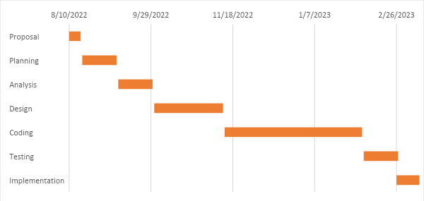

# Chapter 2 Literature Review

## Introduction

Voting is the procedure by which a particular group of individuals makes a choice or expresses an opinion. Different nations utilize various voting procedures to conduct elections. There should be some method of distinct identification used throughout the voting process because elections are conducted by both public bodies, such as the government, and private and public corporate organizations. For physical and distinctive identification as well as verification and authentication reasons, the science of measuring and interpreting biological data (biometrics) such as DNA, fingerprints, eye retinas and irises, voice patterns, facial patterns, and hand measurements can be employed. Devices like the fingerprint scanner have been developed to help identify people and grant access privileges as a result of the principles of human identification.

## Alternate Systems

In [1] an electric voting machine was constructed in India for achieving a fair election system and also to shrink the man power requirements during the elections. In modern era, these electronic voting machines are prone to tampering and electoral frauds which introduces prime challenges for fair election process. However, the prospect of tampering memory chip and double voting are the two main vulnerabilities in this current voting system. Hence, it is essential to modernize the conventional voting systems with a transparent authentication module, security and reliability in order to achieve fairness in the elections. In this work a fingerprint authentication for the voter based on stored data was proposed which enables identification of individuals with high degree of accuracy and GSM feature enhances the transparency of election. Whenever, a fake vote has been casted, and then an alert message for the candidate has been sent to registered mobile number of a voter. The proposed voting system based on Arduino is trustworthy in terms of security, reliability, fairness and transparency of election.

In [2] an electronic voting system (Demotek) was proposed. It is a multi-agent prototype for an electronic voting system based on optical character recognition technology. Trade-offs in voter training, ease of use, security, and coercion across various systems are considered for the purpose of recognizing achievable improvements. Based on the use of N-version programming techniques, they proposed improvements to Demotek, including those in security and new capabilities. This case study demonstrates how the voter's authentication system and vote data transmission could further simplify and improve the electoral process by adding these new capabilities to the electronic voting system using N-version programming.

In [3] a voting system was proposed which uses a peer-to-peer network that is less vulnerable to hacking and manipulation while also being significantly more efficient. The proposed solution is divided into 3 phases and the entire process is transparent and tamper proof. The implementation costs are low, and the votes can be counted in real time. Another benefit is that, the results can be released the same day as the voting. The above-mentioned digital elections are performed using peer-to-peer technology, which makes the entire voting process more secure and reliable.

In [4] an electronic voting system based on blockchain that tackles some of the drawbacks and limitations of current systems and assesses some of the well-known blockchain frameworks in order to build a blockchain-based e-voting system. Blockchain has built-in security features. Basic concepts in blockchain include cryptographic, decentralized, and consensus concepts that guarantee integrity. It's been extremely difficult for a very long time to create a safe and secure electronic voting system that gives the clarity and versatility provided by electronic systems, as well as the transparency and privacy supplied by present voting systems. In this research work, blockchain application is assessed for implementing decentralized electronic voting systems.

In [5] they present the interfacing of online and offline voting systems with an E-Voting website. As per the bylaw of the Constitution of India, the Election Commission of India (ECI) has been driven to conduct elections honestly and autonomously at regular intervals. For this, from the last decade onwards they are implementing advanced technologies in the election process to ensure efficacy, less time consumption, and cost. Right now, the ECI effectively utilizing the Voter-Verified Paper Audit Trail (VVPAT) with an Electronic Voting Machine (EVM) to ensure each individual votes. However, still, the ECI struggling to control malpractice that exists in the election process while verifying voters with an electoral list. To overcome these issues, a face recognition device is embedded with the EVM. The ECI trying to achieve a more than ninety-five percent polling rate in a democratic country. At present, the average polling rate in all types of elections has not reached a mere seventy percent. The ECI is unable to achieve its target due to people migrating from state to state and abroad for employment. The main objective of interfacing online and offline voting systems are to provide opportunities for migrated people to complete vote during elections in their respective constituencies. In this regard, an online website is used for voting which can update the information of voters and their voting status which are acquired through both online and offline voting. The offline voting system implements the usage of the raspberry pi for face recognition. Test results on developed online and offline voting systems with an E-Voting website are found to be satisfactory.

## Conclusion

All of these systems in the research papers are mostly concerned about the security, reliability, transparency and fairness of the voting systems. These methods allowed leeway in experimenting in making an IOT based biometric voting system using fingerprint DNA as unique identification.

# Chapter 3 Analysis

## Information gathering tools

### Observation

The system analyst watches the system in action at this time. Either directly or indirectly is possible. Indirectly, the system analyst employs a collection of cameras to observe the workplace, as opposed to directly going to the workplace and seeing the activities firsthand. When the system analyst participated in the polls, they were able to see the voting process in Zimbabwe firsthand.

#### Advantages

**Directness**: Data can be gathered as it happens. It is not necessary for the observer to question subjects about their actions and reports from others.

**Natural Environment**: Data collected in an observation study represent the observed phenomena as they occur in their natural contexts, unlike data generated using other data gathering procedures, which artificiality into the research environment.

**Longitudinal Analysis**: The observer can conduct his or her research over a much longer period than the survey or experiment since the observation can be done in a natural context.

**Non-Verbal Behavior**: For gathering information about non-verbal behavior, observation is unquestionably preferable to survey research, experimentation, or document study. Some research concentrates on those who are unable to verbally report information or meaningfully express themselves.

#### Disadvantages

**Lack of control**: The presence of a stranger (the observer), as well as the human error associated with observation and data collection, which may remain beyond the observer's control, are likely to considerably skew the observations.

**Difficulties in Quantification**: In contrast to the quantitative measures frequently used in survey and experimental studies, measurement in observational studies typically takes the form of the observer's unquantified perceptions.

**Smallness in sample size**: The sample size is typically maintained to a minimum since observational studies are typically conducted in-depth with data that are frequently subjective and challenging to quantify

### Questionnaire

A questionnaire is a list of questions or items used to solicit information from respondents and they can be used to collect quantitative or qualitative information. Questionnaire methods can be in two forms which are self-administered or researcher-administered. Self-administered questionnaires can be delivered online or in paper and pen formats, in person or through mail. All questions are standardized so that all respondents receive the same questions with identical wording whilst researcher administered questionnaires are interviews that take place by phone, in-person, or online between researchers and respondents. The questionnaire may contain open or closed ended questions. Open ended questions allow respondents to give answers in their own words hence there are no restrictions on their choices whereby closed ended questions offer a fixed set of choices to select from. Questionnaires containing both closed and open ended questions were issued out to three groups of people which are the voters, voter’s registration officers and the ones who would be monitoring the voting and counting process. Each group had a different set of questions.

#### Advantages

**Cost saving**: One of the most economical methods for collecting quantitative data is through questionnaires. A cost-effective technique to rapidly gather voluminous amounts of information from a huge number of people in a very short length of time is to use self-administered questionnaires, where you are not required to engage surveyors to do face-to-face interviews.

**Practical**: In addition to being affordable, questionnaires are an efficient way to obtain information. They may be controlled in a variety of ways and targeted to the groups of your choosing. Both the format and the questions asked are flexible (open-ended or multiple choice). They provide a means to compile a ton of information on any topic. They may be applied in several different contexts, such as consumer feedback.

**Comparability**: Data that has been quantified can be used to gauge change as well as to compare and contrast it with other studies. As a result, surveys conducted monthly or annually become increasingly valuable with time.

**Respondent Anonymity**: Digital surveys offer the greatest sense of privacy and anonymity. This style of questionnaire yields the most truthful responses and works well for all kinds of industries and subjects.

#### Disadvantages

Dishonest Answers: Even though there are numerous benefits to questionnaires, lying can be a problem. It's possible that respondents don't always give honest answers. A number of factors, such as social desirability bias and an effort to maintain privacy, can lead to this. Assuring responders that their privacy is respected and that personal identification is prevented will halt dishonesty in its tracks.

Unanswered Questions: There is a possibility that some questions will go unanswered or overlooked when employing questionnaires. There is always a chance that inquiries won't get addressed if they are not necessary. A straightforward solution to this problem is provided by online questionnaires: make answering the question necessary.

Lack of personalization: Without taking the time and effort to personalize it, any piece of marketing collateral runs the risk of coming across as impersonal. If you can't personalize it, some potential replies might be put off and won't react. This can be especially challenging when the survey or questionnaire is completed willingly on a website, independent of payment or email.

### Interviews

This is a qualitative research technique which involves conducting intensive individual interviews with a small number of respondents to explore their perspectives on a particular idea, program or situation. Interviews can be structured, unstructured or semi-structured. Structured interviews consist of a series of predetermined questions that all interviewees answer in the same order, they are usually straight forward. During unstructured interviews no questions are prepared prior to the interview and data collection is conducted in an informal manner. Semi-structured interviews contain the components of both, structured and unstructured interviews. Semi-structured interviews were held with the people responsible for counting the votes and providing the results.

#### Advantages

* It offers interviewers flexibility.
* The interview receives more responses than sent questionnaires, and those who are illiterate can still participate and respond.
* The interviewer can assess the respondent's nonverbal conduct.
* In contrast to interviews conducted over emails, which can have a completely different setting, the interviewer can choose the location for an interview in a private and quiet spot.
* Like with a questionnaire, the interviewer has control over the question order and can assess the respondent's spontaneity.

#### Disadvantages

* Interview studies can be very time- and money-consuming to conduct.
* Bias might arise during an interview. For instance, the respondent's responses may vary depending on how he perceives the interviewer's race, class, age, or physical attributes.
* Less anonymity is provided by interview research, which is a major worry for many respondents.
* Since respondents can be located in any region of the world or nation, there is a lack of accessibility to respondents (unlike when a study is conducted using mailed questionnaires).

## Description of existing system

The current voting systems are computerized during the voter’s registration process only. An individual’s details including their fingerprints are taken and stored into the database during registration and a register is provided for authenticated voters during election for each polling station. The voting process is done manually where a voter casts a vote on a paper and deposits it in a ballot box which will be submitted later for counting which is done physically by a certain group of authorized people hence the results are then provided to the nation.

## Data Analysis

### UML Context Diagram

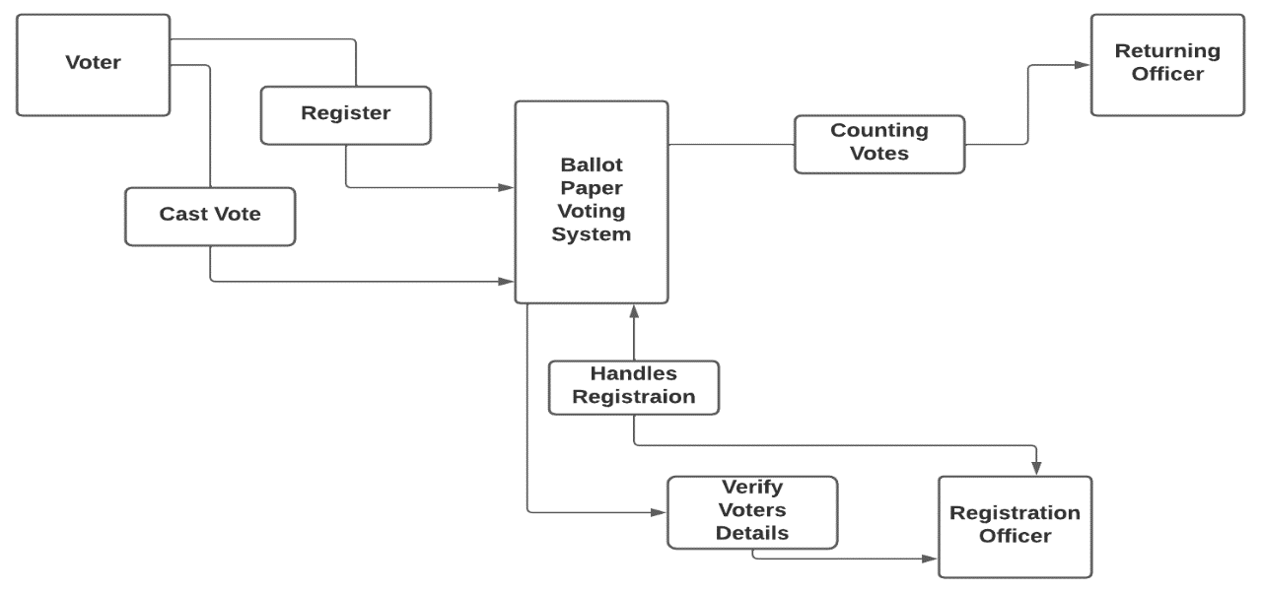

### Data Flow Diagram

#### Level 0 DFD

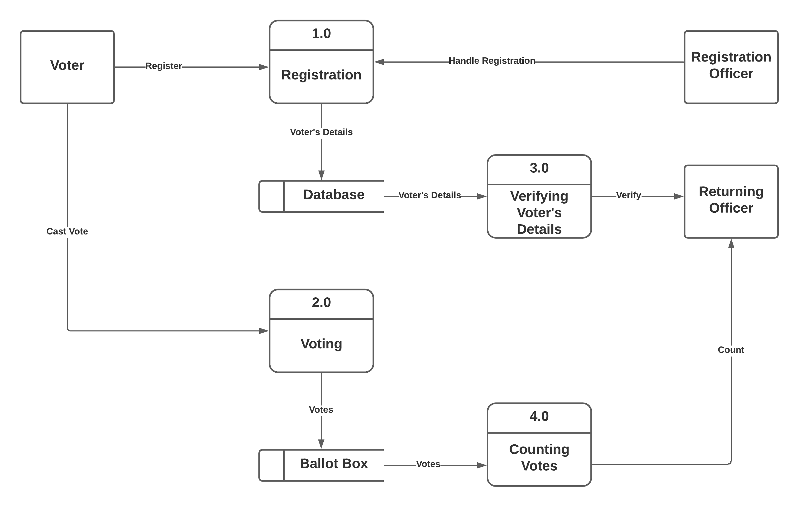

#### Level 1 DFD

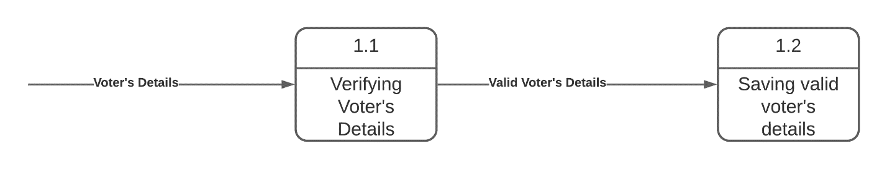

## Evaluation of Alternative Systems

### Functional and Non-Functional Requirements

#### Functional Requirements

The functional requirements of a biometric voting system include well-secured identification and authentication processes for the voter through the use of combined simple biometrics. The design of the system guarantees that no votes in favor of a given candidate are lost, due to improper tallying of the voting counts.

#### Non-Functional Requirements

Flexibility

Security

Performance

Optimization

### Use Case Diagram

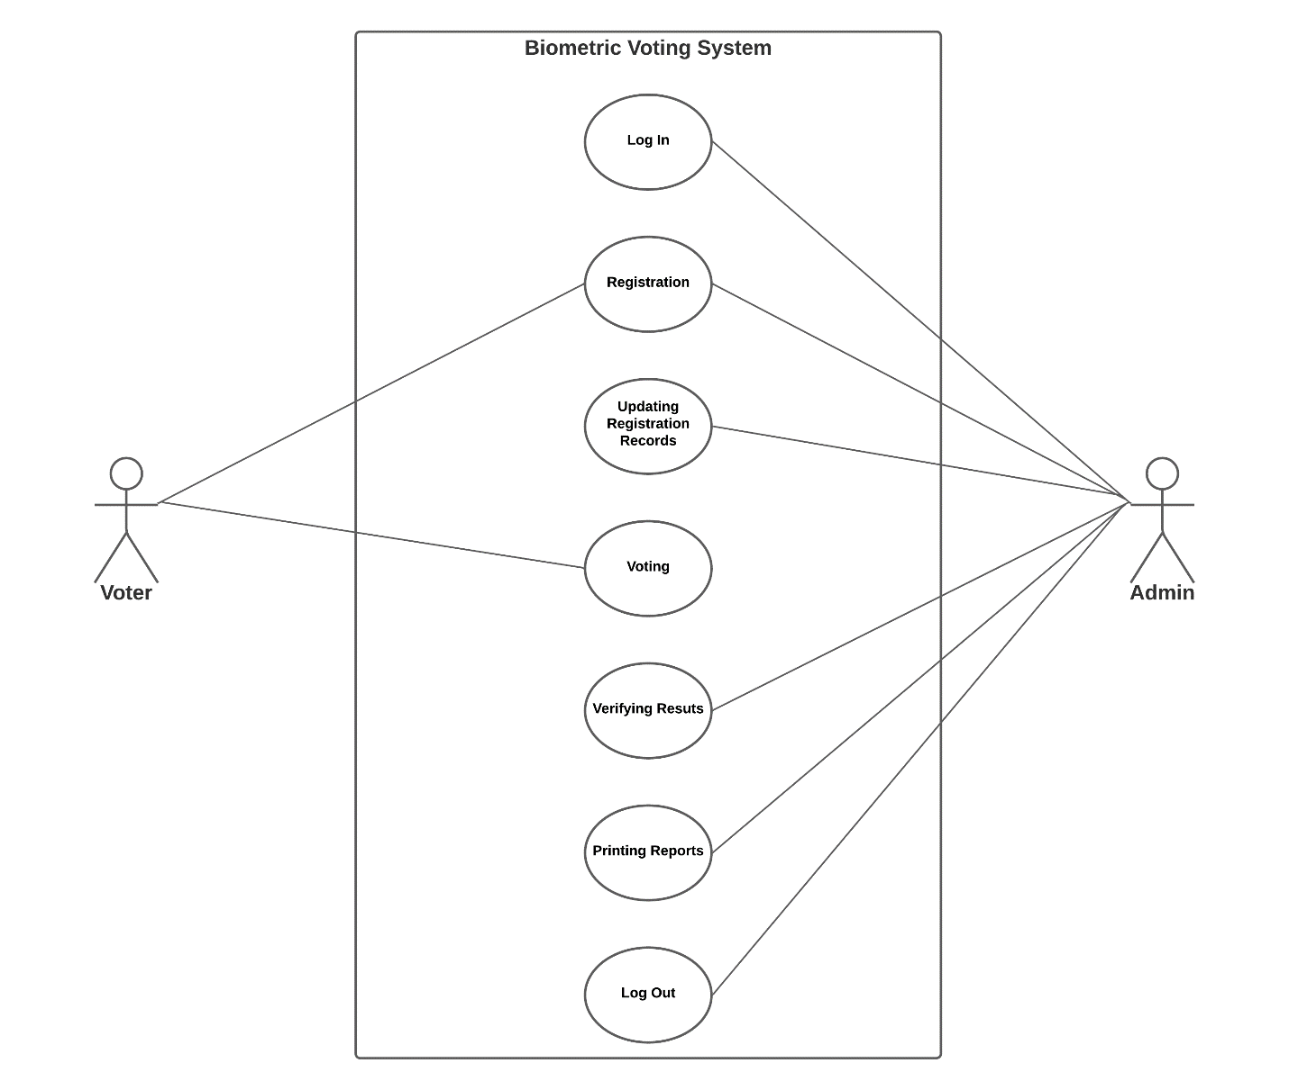

# Chapter 4 Design

## Systems Diagrams

### Context Diagram

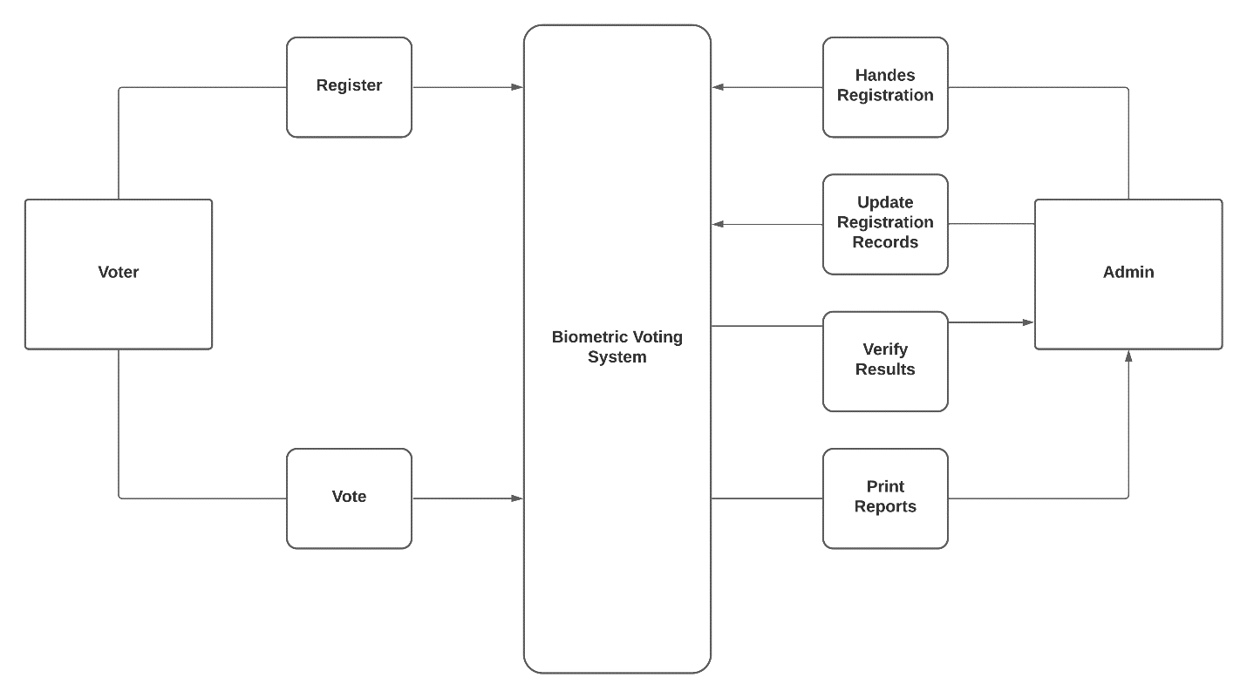

### DataFlow Diagram

#### Level 0

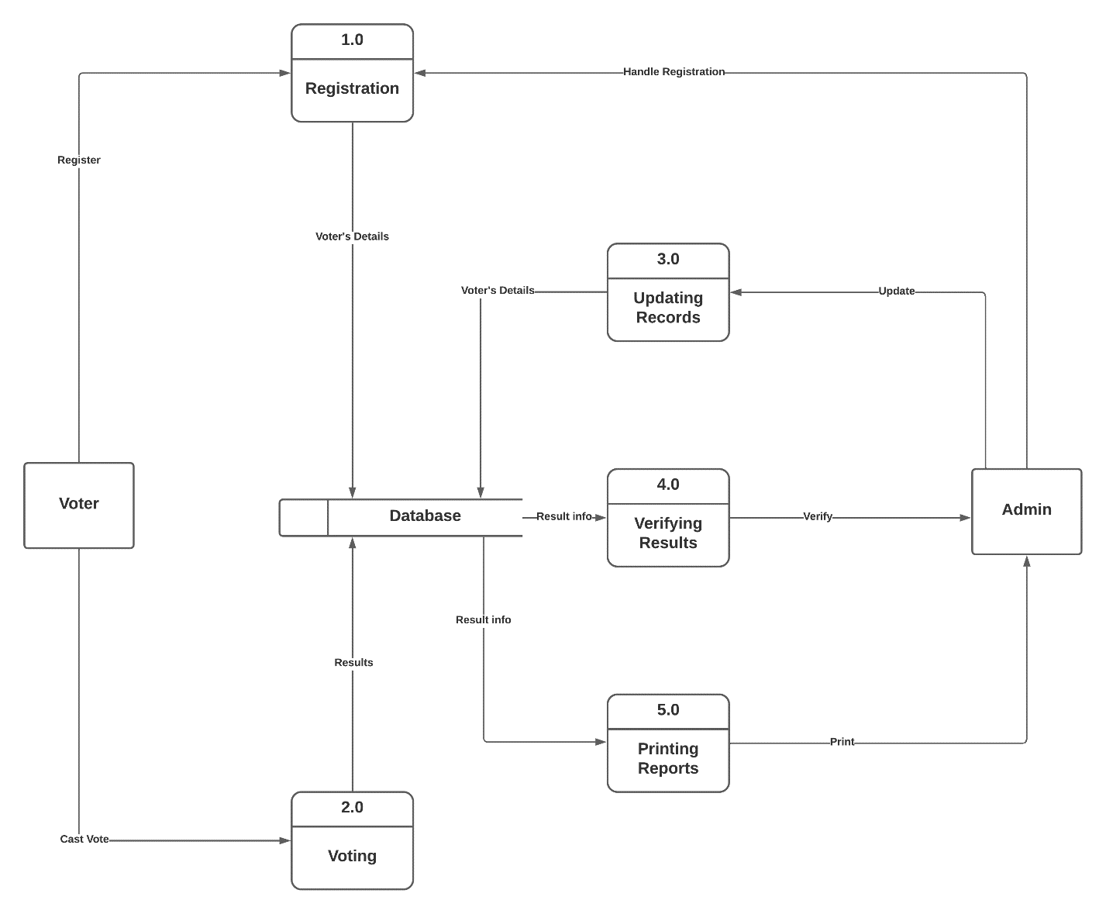

#### Level 1

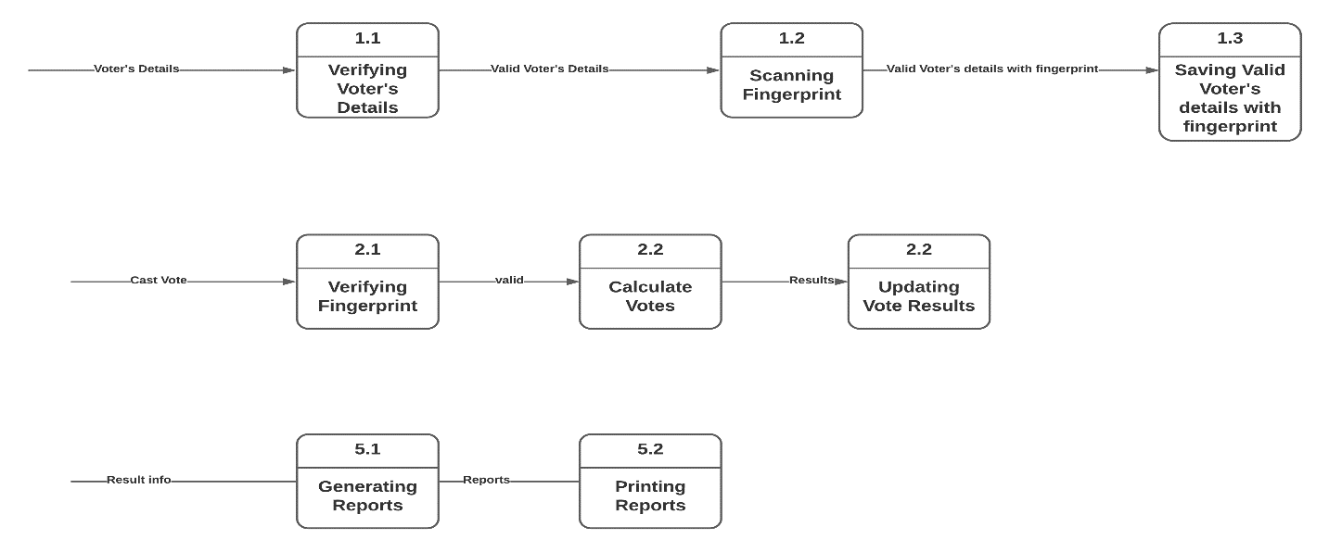

### Activity Diagram

#### Registration Activity

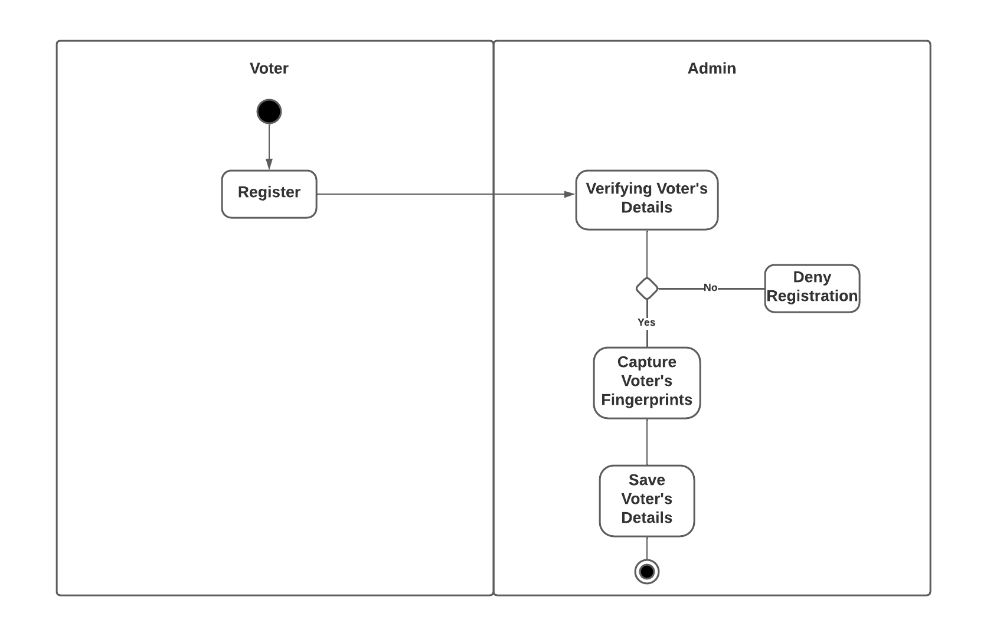

Voting Activity

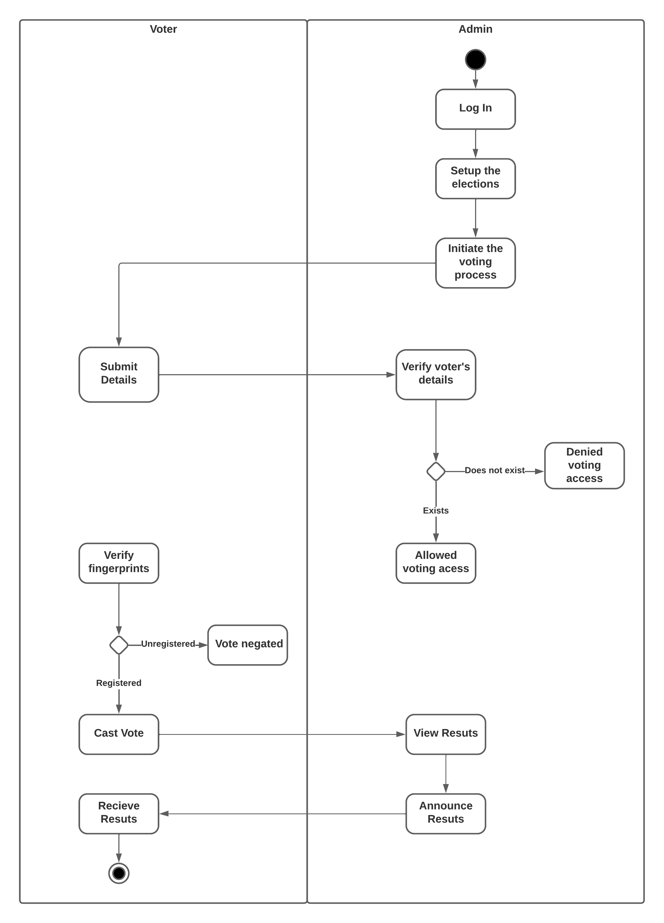

## Architectural Design

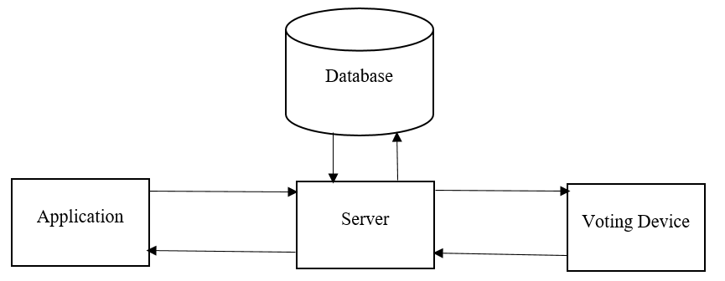

### Hardware (Voting Device)

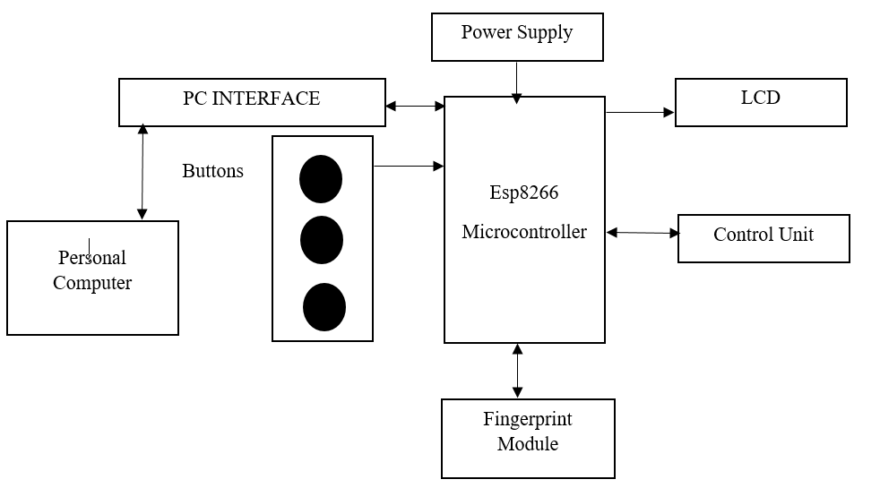

### Networking

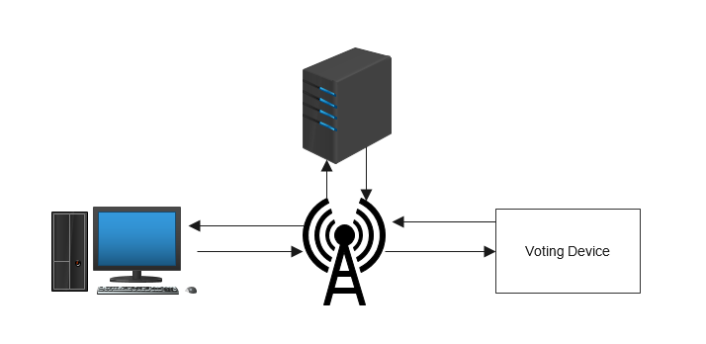

## Database Design

### Entity Relationship Diagram

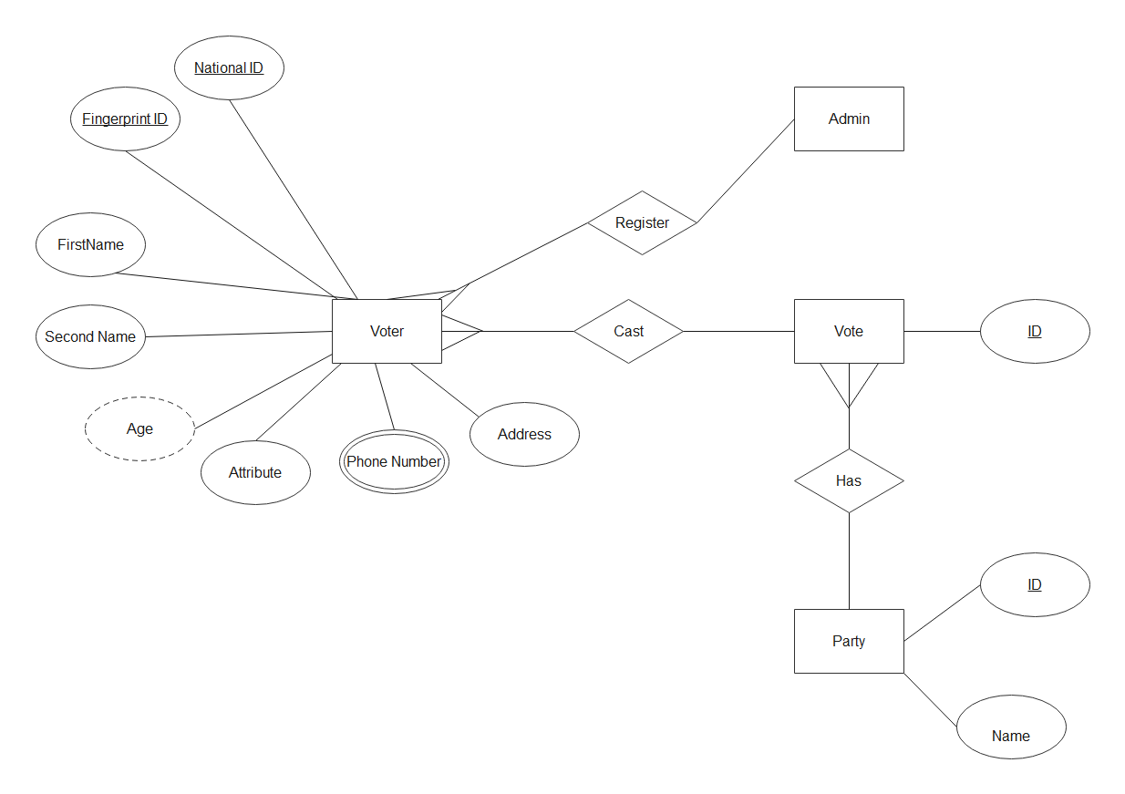

### Normalized Databases

#### First Normal Form

##### Voter’s Role Table

|  |  |  |  |  |  |  |  |  |  |  |  |
| --- | --- | --- | --- | --- | --- | --- | --- | --- | --- | --- | --- |
| Voter ID | First  Name | Last  Name | ID  Number | Gender | Date of Birth | Address | Phone  Number | Province | Finger  print id | Registration Date | Voter Status |
| 1 | Grant | Tsikisayi | 63-2125 860 A 80 | Male | 19-09-99 | 80 Shaftsbury | 0786332413 | Harare | 1 | 23-03-23 | 1 |
| 2 | John | Mukamba | 63-2123 463 B 70 | Male | 15-07-99 | Msasa Park | 0765778765 | Harare | 2 | 25-09-22 | 1 |

##### Voting Results Table

|  |  |  |
| --- | --- | --- |
| ID | Vote Casts | Party Name |
| 1 | 600 | A |
| 2 | 700 | B |
| 3 | 900 | C |

#### Second Normal Form

##### Voter’s Role Table

|  |  |  |  |  |  |  |  |  |  |  |
| --- | --- | --- | --- | --- | --- | --- | --- | --- | --- | --- |
| Voter ID | First  Name | Last  Name | ID  Number | Gender | Date of Birth | Address | Phone  Number | Province | Registration Date | Voter Status |
| 1 | Grant | Tsikisayi | 63-2125 860 A 80 | Male | 19-09-99 | 80 Shaftsbury | 0786332413 | Harare | 23-03-23 | 1 |
| 2 | John | Mukamba | 63-2123 463 B 70 | Male | 15-07-99 | Msasa Park | 0765778765 | Harare | 25-09-22 | 1 |

##### Biometric Data Table

|  |  |
| --- | --- |
| Voter ID | Fingerprint ID |
| 1 | 1 |
| 2 | 2 |

##### Voting results table

#### The table is in second normal form since there are no repeating groups and no partial dependencies.

#### Third Normal Form

##### Voter’s Role Table

The tables are in third normal form because there are no transitive dependencies between non-key columns.

##### Voting results table

The tables are in third normal form because there are no transitive dependencies.

#### Fourth Normal Form

##### Voter’s Role Table

The tables are in fourth normal form because there are no multi-valued dependencies.

##### Voting results table

The tables are in third normal form because there are no multivalued dependencies.

## Program Design

### Class Diagram

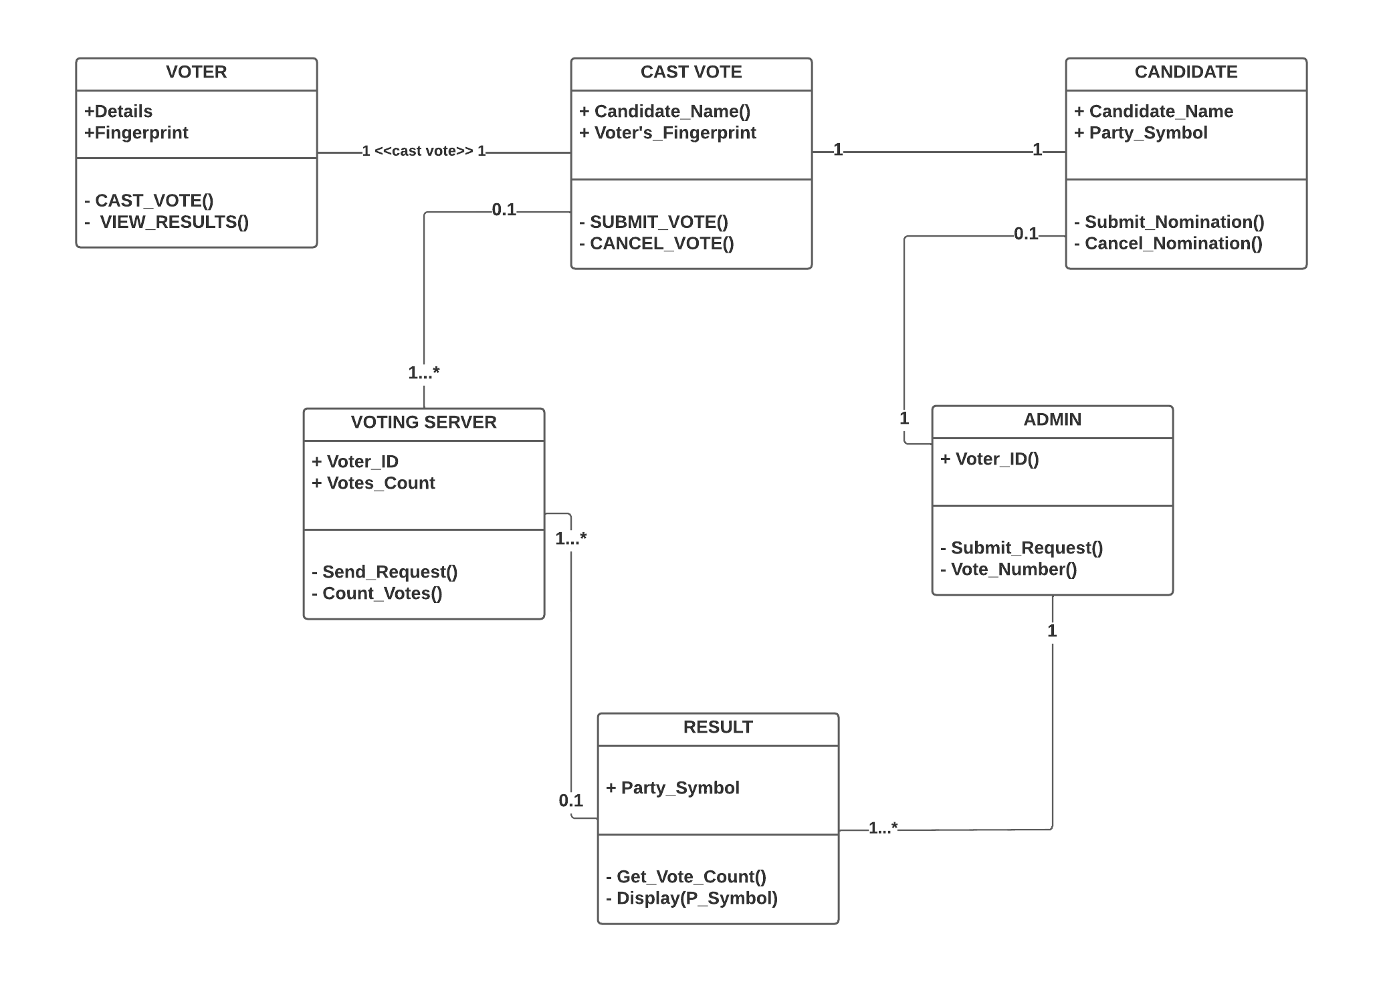

### Sequence Diagram

#### Voter

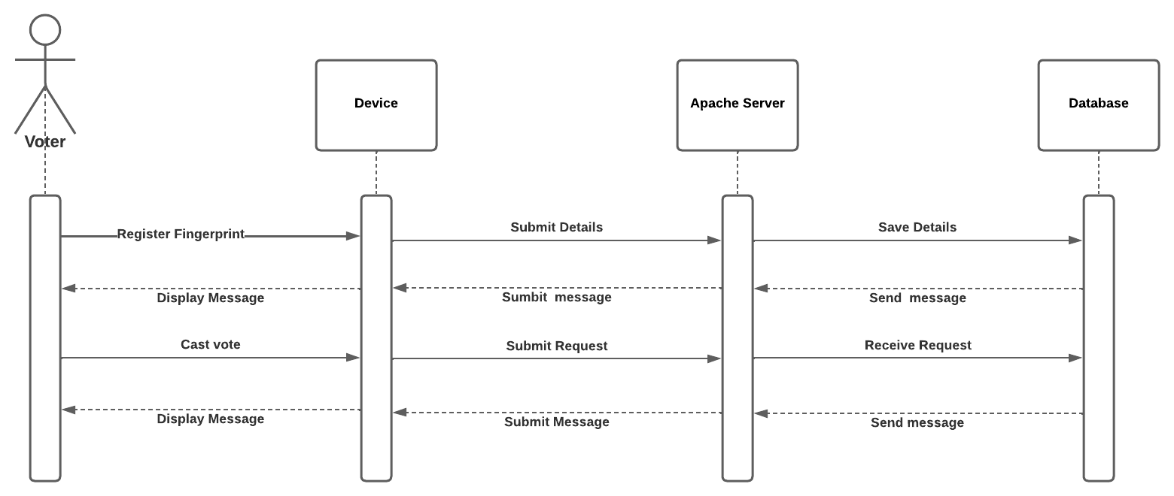

#### Admin

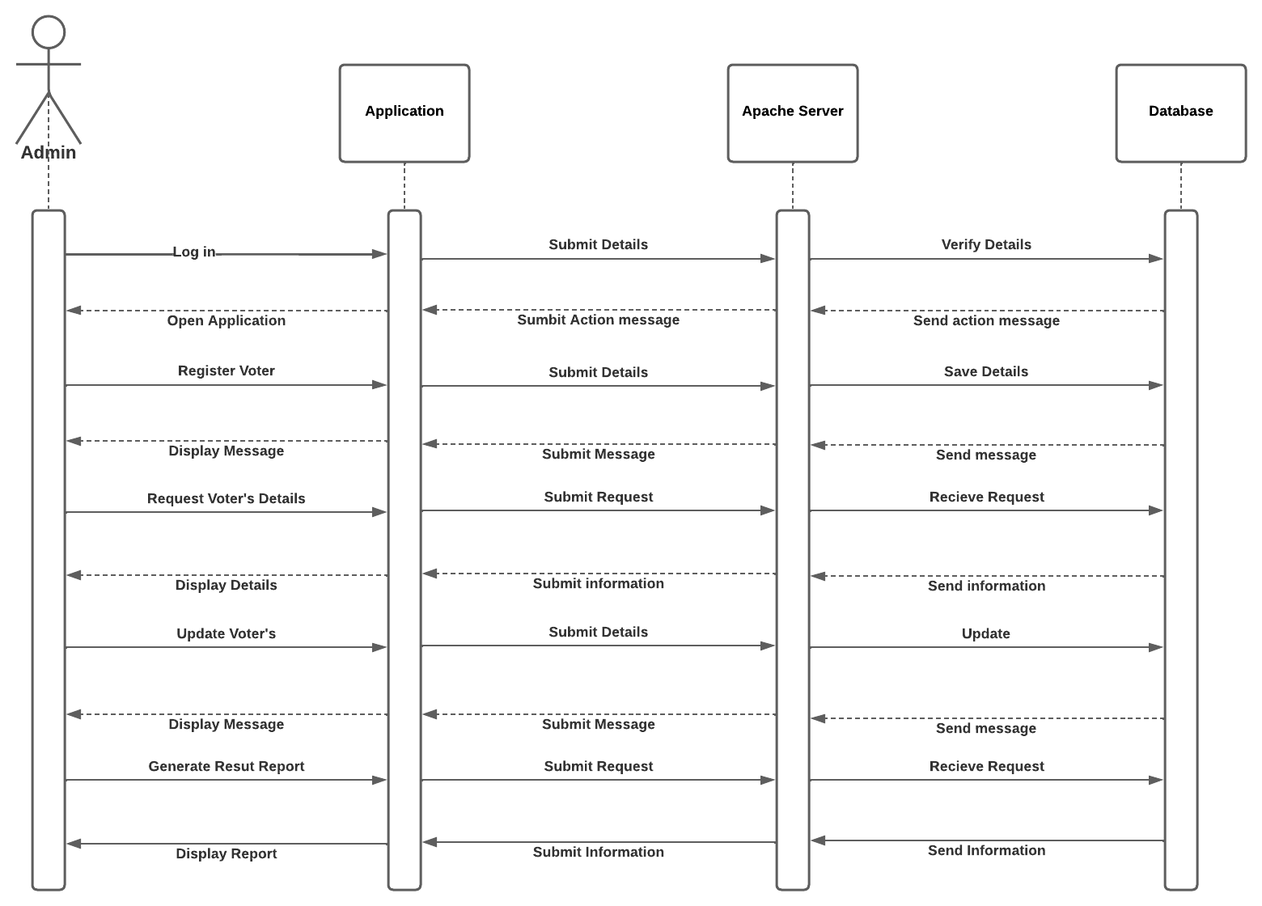

#### Package Diagram

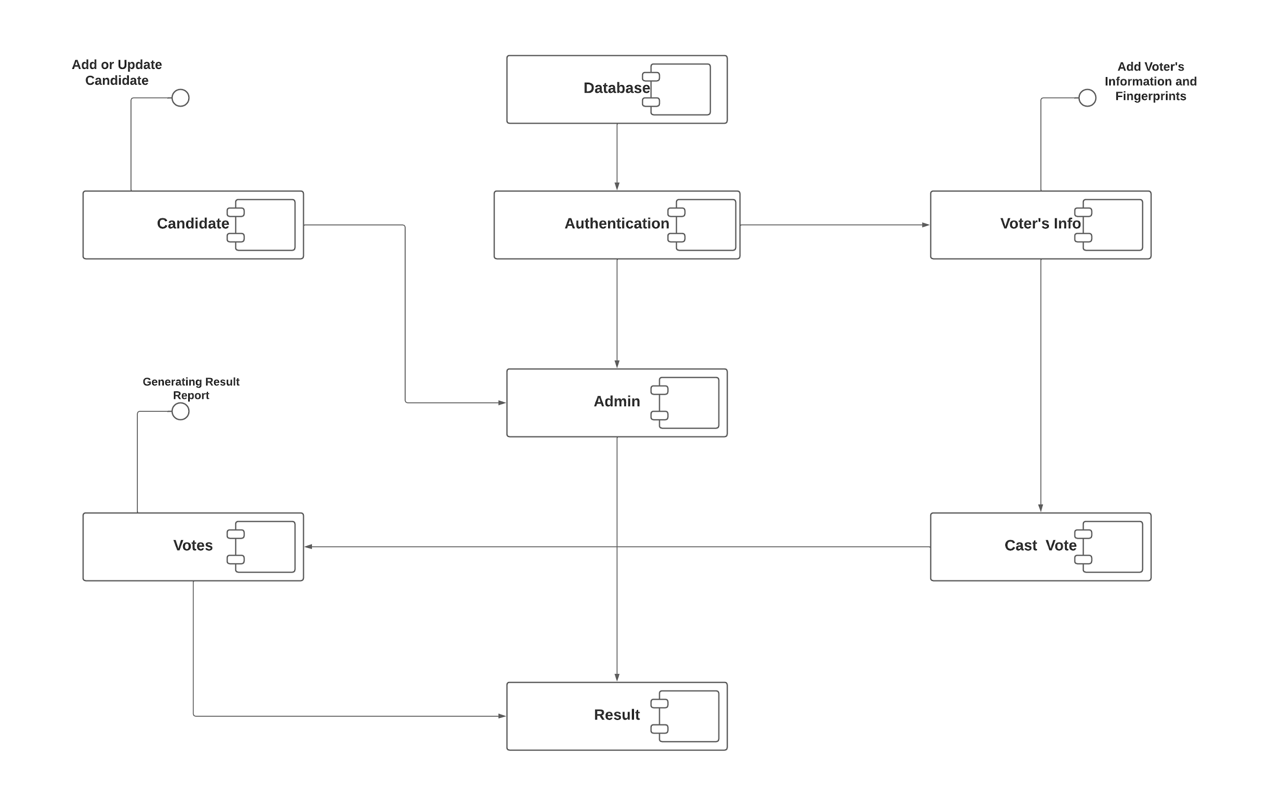

## User Interface Design

### Log In

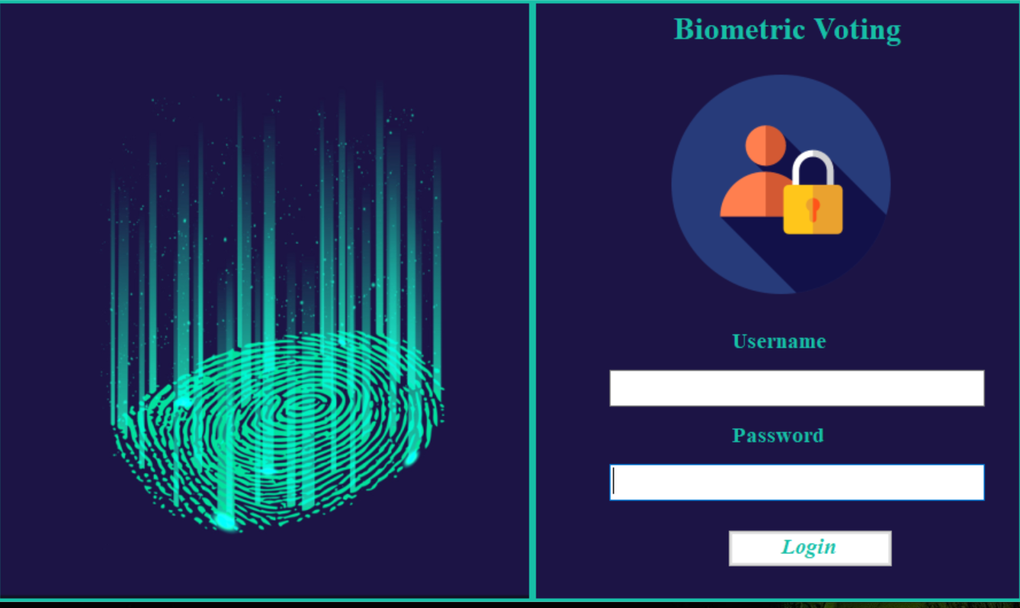

### Registration

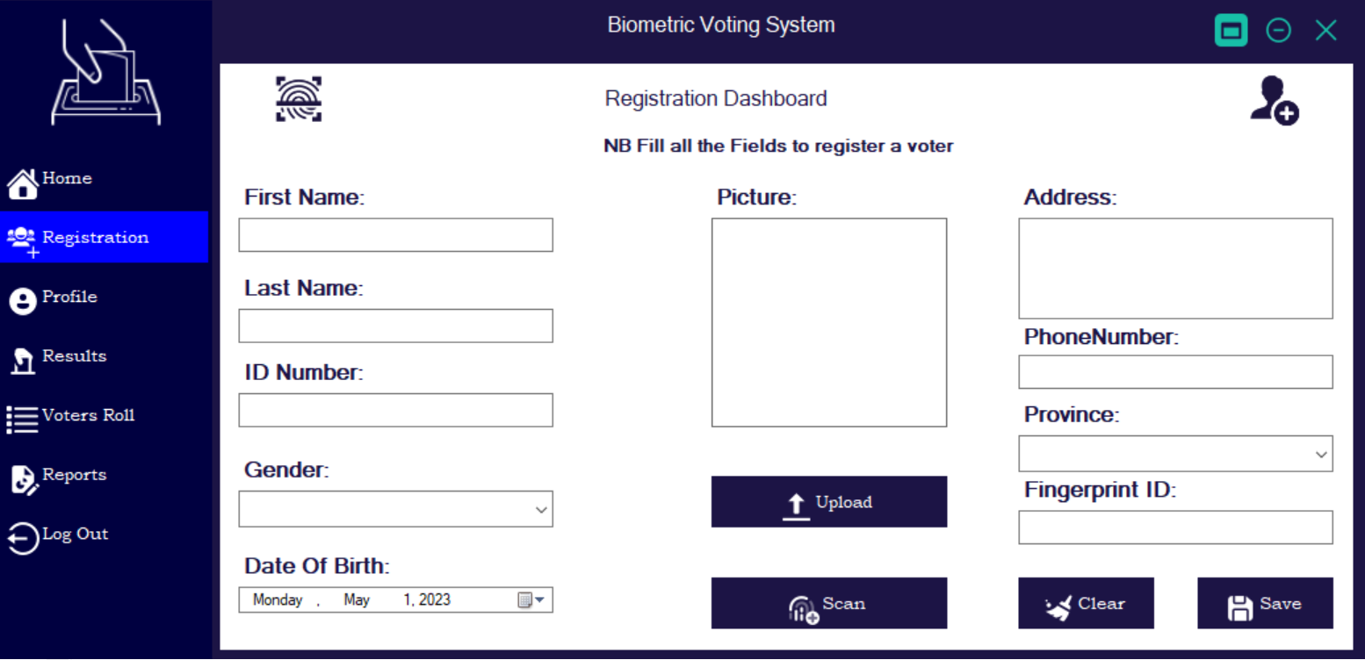

### Voter’s Profile

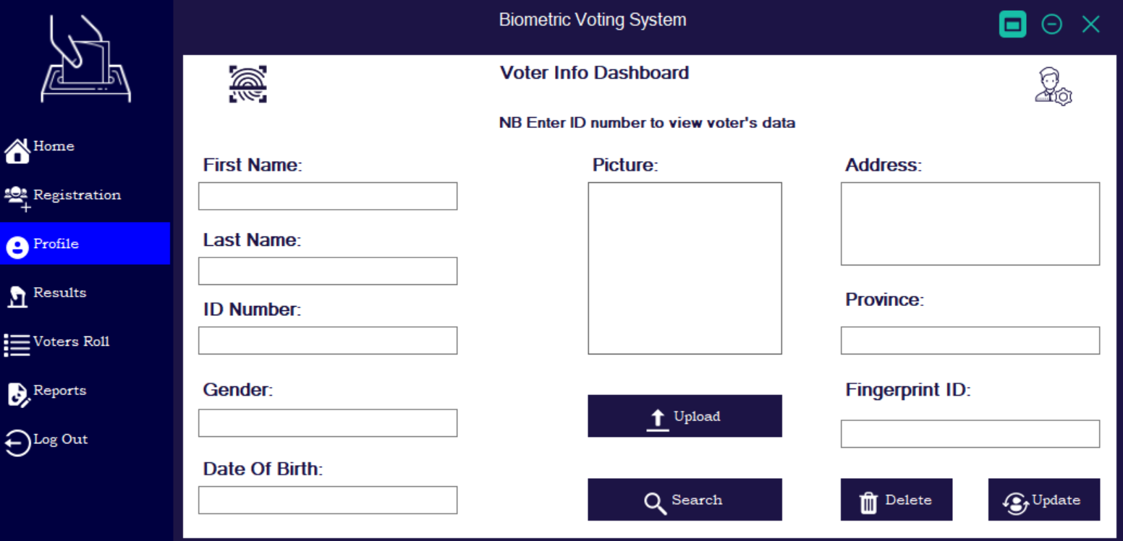

### Results

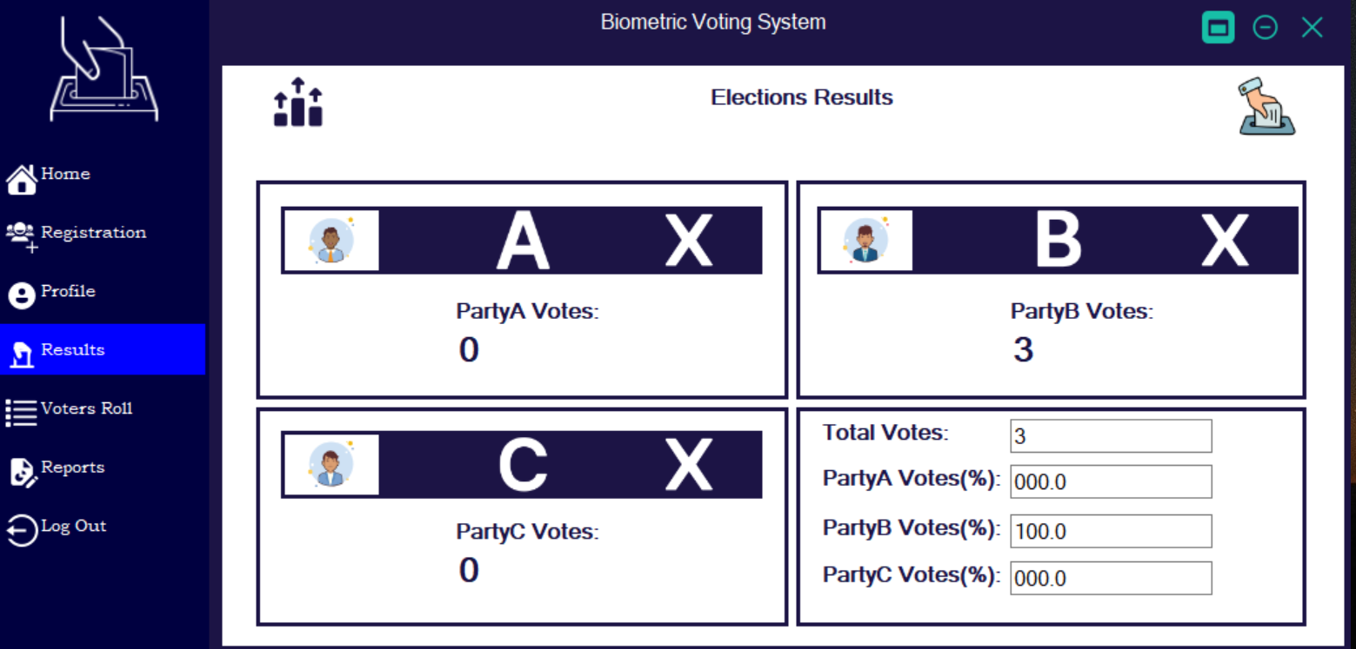

### Voter’s Roll

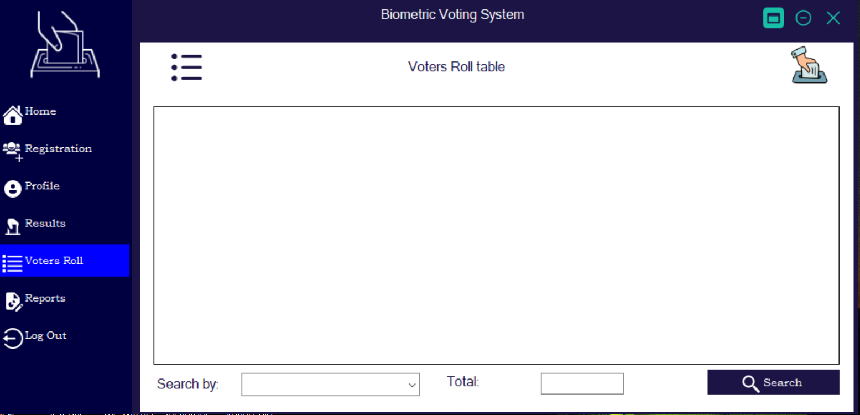

### Reports

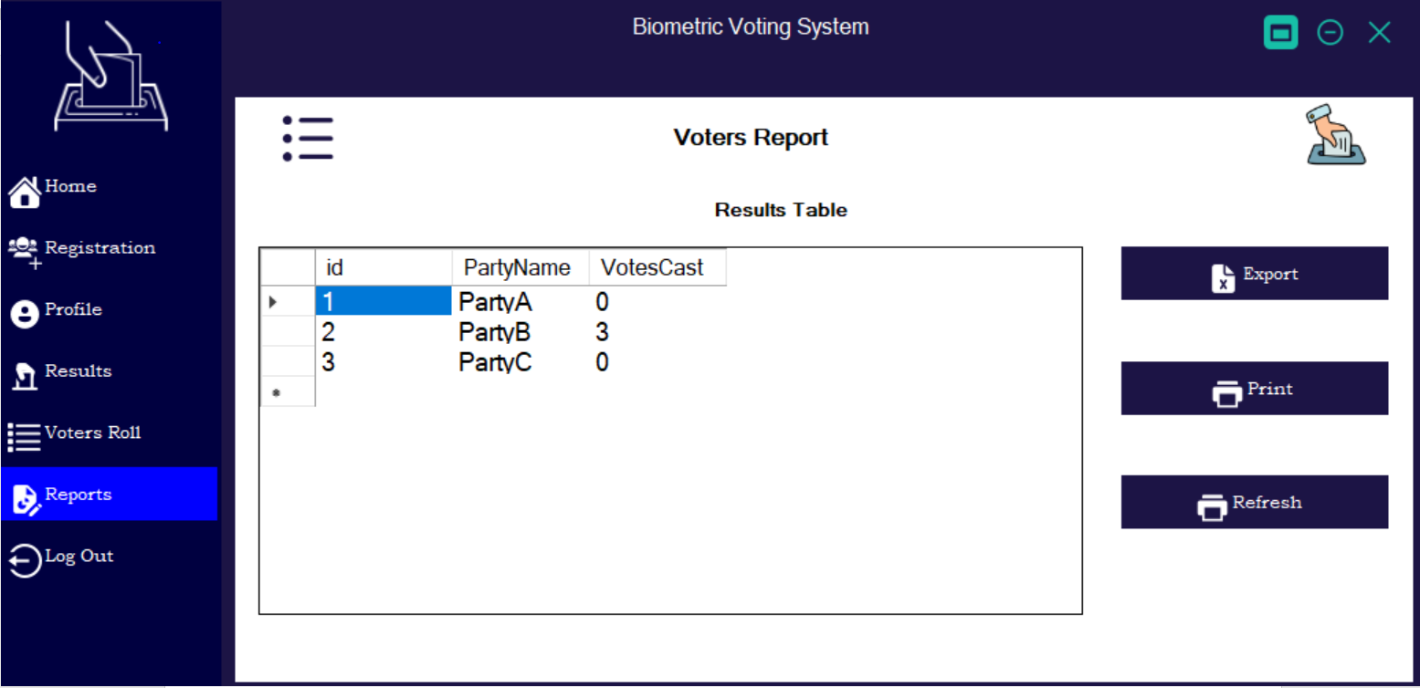

# Chapter 5 Implementation and testing

## Pseudocode

### Voting

This is a piece of C++ code that controls how votes are cast on the hardware side. A voter scans their finger on the voting machine. The fingerprint ID is then cross-referenced with the database answer to determine if the fingerprint has been registered to vote or not as well as its current voting status. When a fingerprint is registered, a party is chosen based on the fingerprint id, and if the fingerprint's voting status is 0, the LCD displays "Alert Voting Successful," otherwise, if it is 1, the LCD displays "Alert voter already voted." If the fingerprint is not registered, the LCD will display "unregistered."

void SendFingerprintID( int finger ) {

//fingerprint recognised

Serial.println(finger); //Print fingerprint ID

Serial.println("recognised");

lcd.clear();

while (1) {

yield();

lcd.setCursor(0, 0);

lcd.print("select party");

if (digitalRead(PartyA) == LOW) {

delay(300);

if (digitalRead(PartyA) == LOW) {

userParty = "PartyA";

lcd.setCursor(0, 1);

lcd.print("PartyA");

delay(3000);

break;

}

}

if (digitalRead(PartyB) == LOW) {

delay(300);

if (digitalRead(PartyB) == LOW) {

userParty = "PartyB";

lcd.setCursor(0, 1);

lcd.print("PartyB");

delay(3000);

break;

}

}

if (digitalRead(PartyC) == LOW) {

delay(300);

if (digitalRead(PartyC) == LOW) {

userParty = "PartyC";

lcd.setCursor(0, 1);

lcd.print("PartyC");

delay(3000);

break;

}

}

}

//functions to post

lcd.clear();

if (WiFi.status() == WL_CONNECTED) {

WiFiClient client;

HTTPClient http;

String myid = String(finger);

http.begin(client, link);

http.addHeader("Content-Type", "application/x-www-form-urlencoded");

String httpRequestData = "myID=" + myid + "&partyName=" + userParty;

int httpCode = http.POST(httpRequestData);

String payload = http.getString(); //Get the response payload

String dbresponse = payload;

if (httpCode > 0) {

// HTTP header has been send and Server response header has been handled

Serial.printf("[HTTP] POST... code: %d\n", httpCode);

// file found at server

if (httpCode == HTTP_CODE_OK) {

const String& payload = http.getString();

String dbresponse;

Serial.println("received payload:\n<<");

Serial.println(payload);

Serial.println(httpRequestData);

Serial.println(">>");

ind1 = payload.indexOf(','); //finds location of first ,

dbresponse = payload.substring(0, ind1); //captures first data String

if (dbresponse == "Already") {

lcd.setCursor(0, 0);

lcd.print("Alert Voter");

lcd.setCursor(0, 1);

lcd.print("Already Voted");

delay(4000);

lcd.clear();

}

if (dbresponse == "Votecast") {

lcd.setCursor(0, 0);

lcd.print("Alert Voting");

lcd.setCursor(0, 1);

lcd.print("Successful!!");

delay(4000);

lcd.clear();

}

if (dbresponse == "Unregistered") {

lcd.setCursor(0, 0);

lcd.print("Alert Voter");

lcd.setCursor(0, 1);

lcd.print("Unregistered");

delay(4000);

lcd.clear();

}

}

}

else {

Serial.printf("[HTTP] POST... failed, error: %s\n", http.errorToString(httpCode).c_str());

}

http.end();

}

else {

Serial.println("WiFi Disconnected");

}

}

int getFingerprintID() {

uint8_t p = finger.getImage();

switch (p) {

case FINGERPRINT_OK:

//Serial.println("Image taken");

break;

case FINGERPRINT_NOFINGER:

//Serial.println("No finger detected");

return 0;

case FINGERPRINT_PACKETRECIEVEERR:

//Serial.println("Communication error");

return -2;

case FINGERPRINT_IMAGEFAIL:

//Serial.println("Imaging error");

return -2;

default:

//Serial.println("Unknown error");

return -2;

}

// OK success!

p = finger.image2Tz();

switch (p) {

case FINGERPRINT_OK:

break;

case FINGERPRINT_IMAGEMESS:

return -1;

case FINGERPRINT_PACKETRECIEVEERR:

return -2;

case FINGERPRINT_FEATUREFAIL:

return -2;

case FINGERPRINT_INVALIDIMAGE:

return -2;

default:

return -2;

}

// OK converted!

p = finger.fingerFastSearch();

if (p == FINGERPRINT_OK) {

} else if (p == FINGERPRINT_PACKETRECIEVEERR) {

return -2;

} else if (p == FINGERPRINT_NOTFOUND) {

return -1;

} else {

return -2;

}

return finger.fingerID;

}

void DisplayFingerprintID() {

//Fingerprint has been detected

if (FingerID > 0) {

SendFingerprintID( FingerID );

}

//---------------------------------------------

//No finger detected

else if (FingerID == 0) {

lcd.setCursor(0, 0);

lcd.print("Place finger");

}

//---------------------------------------------

//Didn't find a match

else if (FingerID == -1) {

//Serial.println("didnt find a match");

lcd.setCursor(0, 1);

lcd.print("Unregistered");

delay(1500);

lcd.clear();

}

//---------------------------------------------

//Didn't find the scanner or there an error

else if (FingerID == -2) {

//Serial.println("didnt find the scanner or there an error");

}

}

During the voting process, this php code is in charge of establishing a connection between the hardware and the database on the server. It responds by informing the hardware whether or not a fingerprint has been recorded and whether a vote has been cast (1 or 0). This code also updates the voter's voting status in the database and adds the cast votes.

if (isset($_POST['myID']) && isset($_POST['partyName'])) {

$scannedID = $_POST['myID'];

$votedParty = $_POST['partyName'];

$mysqli = new mysqli("localhost","root","","voting_db");

$result = $mysqli->query("SELECT * FROM voters_roll WHERE FingerprintID = '$scannedID'");

if($result->num_rows == 0) {

// row not found, do stuff...

echo 'Unregistered,';

} else {

// do other stuff...

while ($row = mysqli_fetch_array($result)) {

$VoterStatus = $row["VoterStatus"];

if($VoterStatus == 0){

$mysqli = new mysqli("localhost","root","","voting_db");

$result = $mysqli->query("SELECT * FROM votingresults WHERE PartyName = '$votedParty'");

if($result->num_rows == 0) {

// row not found, do stuff...

//echo 'Party Not in database';

} else {

// do other stuff...

while ($row = mysqli_fetch_array($result)) {

$Votecast = $row["VotesCast"];

$newresult = $Votecast + 1;

$sql = "UPDATE `voters_roll` SET `VoterStatus` ='"."1"."' WHERE FingerprintID = '".$scannedID."';";

$sql.= "UPDATE `votingresults` SET `VotesCast` ='".$newresult."' WHERE PartyName = '".$votedParty."';";

$db->multi_query($sql);

echo 'Votecast,';

}

}

}

else{

echo 'Already,';

}

}

}

$mysqli->close();

}

### Registration

This bit of C# code is in charge of obtaining data from the user interface and saving it to the database. Additionally, it gives the voter's data a fingerprint ID to serve as a reference and demonstrate that the fingerprint was correctly scanned.

void BtnUploadClick(object sender, EventArgs e)

{

OpenFileDialog open = new OpenFileDialog();

open.Filter = "Image Files(* .jpg; * .jpeg; * .png;)|* .jpg; * .jpeg; * .png;";

if(open.ShowDialog() == DialogResult.OK){

picVoter.Image = new Bitmap(open.FileName);

myPath = Path.GetFileName(open.FileName);

}

}

void BtnSaveClick(object sender, EventArgs e)

{

if (String.IsNullOrEmpty(txtFirstName.Text)||String.IsNullOrEmpty(txtLastName.Text)||String.IsNullOrEmpty(txtIDNumber.Text)||String.IsNullOrEmpty(cmbGender.Text)||String.IsNullOrEmpty(txtAddress.Text)||String.IsNullOrEmpty(cmbProvince.Text)||String.IsNullOrEmpty(txtFingerprint.Text)||picVoter.Image == null){

MessageBox.Show("Please Fill all the Fields");

}

else{

con = new MySqlConnection();

con.ConnectionString = ConnectionString;

con.Open();

query = "SELECT * FROM voters_roll WHERE FingerprintID = ('" + txtFingerprint.Text +"') OR IDNumber = ('"+ txtIDNumber.Text +"')" ;

MySqlCommand cmd = new MySqlCommand(query,con);

MySqlDataReader dataReader = cmd.ExecuteReader();

dataReader.Read();

if(dataReader.HasRows){

MessageBox.Show("Either FingerprintID or ID Number exist in voters roll");

}

else{

string theDate = dateTimePicker1.Value.ToString("yyyy-MM-dd");

string theProvince = cmbProvince.SelectedItem.ToString();

string theGender = cmbGender.SelectedItem.ToString();

con = new MySqlConnection();

con.ConnectionString = ConnectionString;

con.Open();

query = "INSERT INTO voters_roll (FirstName,LastName,IDNumber,Gender,DateOfBirth,Photo,Address,PhoneNumber,Province,FingerprintID) VALUES('" + txtFirstName.Text + "','" + txtLastName.Text + "','" + txtIDNumber.Text + "','" + theGender + "','" + theDate + "','" + myPath +"','" + txtAddress.Text + "','" + txtPhoneNumber.Text + "','" + theProvince + "','" + txtFingerprint.Text + "')";

cmd = new MySqlCommand(query,con);

cmd.ExecuteNonQuery();

con.Close();

MessageBox.Show("Registration Successfull");

txtAddress.Text = txtFingerprint.Text = txtFirstName.Text = txtIDNumber.Text = txtLastName.Text = txtPhoneNumber.Text = "";

cmbProvince.SelectedIndex = -1;

cmbGender.SelectedIndex = -1;

picVoter.Image = null;

}

}

}

void BtnScanClick(object sender, EventArgs e)

{

con = new MySqlConnection();

con.ConnectionString = ConnectionString;

con.Open();

query = "SELECT * FROM fingerprintstemplates";

MySqlCommand cmd = new MySqlCommand(query,con);

MySqlDataReader dataReader = cmd.ExecuteReader();

dataReader.Read();

if(dataReader.HasRows){

string myFinger = dataReader["FingerprintID"] + "";

int capFinger = Convert.ToInt16(myFinger);

con.Close();

capFinger = capFinger + 1;

myFinger = Convert.ToString(capFinger);

txtFingerprint.Text = myFinger;

con = new MySqlConnection();

con.ConnectionString = ConnectionString;

con.Open();

query = "UPDATE `fingerprintstemplates` SET FingerprintID = ('"+ myFinger + "'), Status = ('"+ "0" +"') WHERE id = ('" + "1" +"')";

cmd = new MySqlCommand(query,con);

dataReader = cmd.ExecuteReader();

dataReader.Read();

con.Close();

}

}

This c++ code snippet registers a fingerprint to the database during device registration. Prior to registering a fingerprint, another check is made to see if the connection to the database server is operational. The LCD will read "Enrolled ID showing the assigned id of the fingerprint" after a fingerprint has been successfully enrolled.

void BtnUploadClick(object sender, EventArgs e)

{

OpenFileDialog open = new OpenFileDialog();

open.Filter = "Image Files(* .jpg; * .jpeg; * .png;)|* .jpg; * .jpeg; * .png;";

if(open.ShowDialog() == DialogResult.OK){

picVoter.Image = new Bitmap(open.FileName);

myPath = Path.GetFileName(open.FileName);

}

}

void BtnSaveClick(object sender, EventArgs e)

{

if (String.IsNullOrEmpty(txtFirstName.Text)||String.IsNullOrEmpty(txtLastName.Text)||String.IsNullOrEmpty(txtIDNumber.Text)||String.IsNullOrEmpty(cmbGender.Text)||String.IsNullOrEmpty(txtAddress.Text)||String.IsNullOrEmpty(cmbProvince.Text)||String.IsNullOrEmpty(txtFingerprint.Text)||picVoter.Image == null){

MessageBox.Show("Please Fill all the Fields");

}

else{

con = new MySqlConnection();

con.ConnectionString = ConnectionString;

con.Open();

query = "SELECT * FROM voters_roll WHERE FingerprintID = ('" + txtFingerprint.Text +"') OR IDNumber = ('"+ txtIDNumber.Text +"')" ;

MySqlCommand cmd = new MySqlCommand(query,con);

MySqlDataReader dataReader = cmd.ExecuteReader();

dataReader.Read();

if(dataReader.HasRows){

MessageBox.Show("Either FingerprintID or ID Number exist in voters roll");

}

else{

string theDate = dateTimePicker1.Value.ToString("yyyy-MM-dd");

string theProvince = cmbProvince.SelectedItem.ToString();

string theGender = cmbGender.SelectedItem.ToString();

con = new MySqlConnection();

con.ConnectionString = ConnectionString;

con.Open();

query = "INSERT INTO voters_roll (FirstName,LastName,IDNumber,Gender,DateOfBirth,Photo,Address,PhoneNumber,Province,FingerprintID) VALUES('" + txtFirstName.Text + "','" + txtLastName.Text + "','" + txtIDNumber.Text + "','" + theGender + "','" + theDate + "','" + myPath +"','" + txtAddress.Text + "','" + txtPhoneNumber.Text + "','" + theProvince + "','" + txtFingerprint.Text + "')";

cmd = new MySqlCommand(query,con);

cmd.ExecuteNonQuery();

con.Close();

MessageBox.Show("Registration Successfull");

txtAddress.Text = txtFingerprint.Text = txtFirstName.Text = txtIDNumber.Text = txtLastName.Text = txtPhoneNumber.Text = "";

cmbProvince.SelectedIndex = -1;

cmbGender.SelectedIndex = -1;

picVoter.Image = null;

}

}

}

void BtnScanClick(object sender, EventArgs e)

{

con = new MySqlConnection();

con.ConnectionString = ConnectionString;

con.Open();

query = "SELECT * FROM fingerprintstemplates";

MySqlCommand cmd = new MySqlCommand(query,con);

MySqlDataReader dataReader = cmd.ExecuteReader();

dataReader.Read();

if(dataReader.HasRows){

string myFinger = dataReader["FingerprintID"] + "";

int capFinger = Convert.ToInt16(myFinger);

con.Close();

capFinger = capFinger + 1;

myFinger = Convert.ToString(capFinger);

txtFingerprint.Text = myFinger;

con = new MySqlConnection();

con.ConnectionString = ConnectionString;

con.Open();

query = "UPDATE `fingerprintstemplates` SET FingerprintID = ('"+ myFinger + "'), Status = ('"+ "0" +"') WHERE id = ('" + "1" +"')";

cmd = new MySqlCommand(query,con);

dataReader = cmd.ExecuteReader();

dataReader.Read();

con.Close();

}

}

This php code snippet is responsible for saving the fingerprint templates into the database on the server side based on data from the hardware. It is also accountable for updating a voter's database registration status.

if (isset($_POST['Registration']))

{

$theID = 1;

$regstatus = $_POST['Registration'];

if($regstatus == 0){

$mysqli = new mysqli("localhost","root","","voting_db");

$result = $mysqli->query("SELECT * FROM fingerprintstemplates WHERE id = '$theID'");

if($result->num_rows == 0) {

// row not found, do stuff...

echo 'Unregistered';

} else {

// do other stuff...

while ($row = mysqli_fetch_array($result)) {

$myFinger = $row["FingerprintID"];

$myStatus = $row["Status"];

if($myStatus == 0){

echo $myFinger;

}

if($myStatus == 1){

echo 'ok';

}

}

}

}

if($regstatus == 1){

$sql = mysqli_query($db,"UPDATE `fingerprintstemplates` SET `Status` ='"."1"."' WHERE id = '".$theID."';");

}

}

else{

echo 'hapana chauya';

}

## System Testing

### Unit Testing

|  |  |  |  |  |
| --- | --- | --- | --- | --- |
| **Component** | **Function** | **Input** | **Expected Output** | **Pass/Fail** |
| Fingerprint Registration System | Capture and store fingerprints correctly. | Voter’s fingerprint. | Voter’s fingerprint is stored correctly. | pass |
| Fingerprint Registration System | Handle errors and exceptions gracefully. | Invalid fingerprint input. | Error message is displayed. | pass |
| Fingerprint Voting System | Authenticate voters using their fingerprints. | Voter’s fingerprint. | Voter is authenticated correctly. | pass |
| Fingerprint Voting System | Record votes correctly. | Voter’s vote. | Voter’s vote is recorded correctly. | pass |
| Fingerprint Voting System | Handle errors and exceptions gracefully. | Invalid vote input. | Error message is displayed. | pass |
| Generating Results Report System | Generate reports correctly based on the votes casted by voters. | Votes casted by voters. | Reports are generated correctly based on the votes casted by voters. | pass |
| Database | Store voter information correctly from the fingerprint registration system. | Voter’s information from the fingerprint registration system. | Voter’s information is stored correctly from the fingerprint registration system. | pass |
| Database | Store vote information correctly from the fingerprint voting system. | Voter’s vote from the fingerprint voting system. | Voter’s vote is stored correctly from the fingerprint voting system. | pass |

### Integration Testing

|  |  |  |  |  |
| --- | --- | --- | --- | --- |
| **Component** | **Function** | **Input** | **Expected Output** | **Pass/Fail** |
| Fingerprint Registration System and Universal Database Integration Testing | Verify that the fingerprint registration system is able to store voter information correctly in the universal database module. | Voter’s information from the fingerprint registration system module. | Voter’s information is stored correctly in the universal database module. | pass |
| Fingerprint Voting System and Universal Database Integration Testing | Verify that the fingerprint voting system module is able to store vote information correctly in the universal database module. | Voter’s vote from the fingerprint voting system module. | Voter’s vote is stored correctly in the universal database module. | pass |
| Generating Results Report System and Universal Database Integration Testing | Verify that the generating results report system module is able to generate reports correctly based on the votes casted by voters stored in the universal database module. | Votes casted by voters stored in the universal database module. | Reports are generated correctly based on the votes casted by voters stored in the universal database module. | pass |

### System Testing

System testing is a level of testing that validates the complete and fully integrated software product. The purpose of system testing is to evaluate the end-to-end system specifications. Usually, the software is only one element of a larger computer-based system. Ultimately, the software is interfaced with other software/hardware systems. Hence the whole system was tested and the results are provided in the following sections.

### Database Testing

* Verify that the voter's fingerprint is registered and stored in the database.
* Verify that the voter's details such as name, age, voter ID, and place of the voter are stored in the database.
* Verify that the voter's fingerprint is fetched from the database when voting.
* Verify that the voter's details are fetched from the database when voting.

### Acceptance Testing

|  |  |  |  |  |
| --- | --- | --- | --- | --- |
| **Component** | **Function** | **Input** | **Expected Output** | **Pass/Fail** |
| Fingerprint registration system | Collect and store civil and biometric data for the entire voting population securely | Civil and biometric data for the entire voting population | Data is stored securely | pass |
| Fingerprint voting system | Allow the voter to vote through their fingerprint | Voter’s fingerprint | Voter is able to vote through their fingerprint as expected | pass |
| Fingerprint voting system | Promise the right to vote a candidate only once | Voter’s fingerprint and candidate’s name | Voter is able to vote a candidate only once as expected | pass |
| Counting votes system | Resolve any algorithmic issues that may arise during counting votes process | Algorithmic issues that may arise during counting votes process | Algorithmic issues are resolved as expected during counting votes process | pass |

## Installation and Deployment

A zip folder containing all the setups and packages essential for this system to work will be provided.

**N/B DO NOT CHANGE ANY CODE WHICH IS NOT MENTIONED IN THE INSTRUCTIONS AND INSTALL THE TOOLS AND PACKAGES IN THE ZIP FOLDER**

### Setting up the System

* Extract the zip folder and install Xampp, MySQL-connector and Arduino.
* Copy the voter’s folder from the extracted folder and place it into the htdocs folder which is in the Xampp folder.
* Run the Xampp application and start the apache and MySQL modules.
* Open admin on the MySQL module and create a database called voting_db.
* Import a database file in the extracted folder to the one you have created.
* Connect your computer to a network and note down its IP address.
* Open the Arduino code fie in the extracted folder and change the IP address to the one you have.
* Connect the voting device to your machine with a data cable and under tools on the Arduino menu select the port of the device (usually COM 3 or COM4).
* Click the arrow pointing to the right on the Arduino menu to upload the code into the device.
* Navigate to the debug file and run the Voting_Biometric application from the Voting_Biometric folder in the extracted folder.

## Maintenance

* Make sure to update the IP address if it changes before starting the system.
* Make sure the device is kept in a safe place where it does not get damaged.
* Use sharp development for maintaining the application.

# Chapter 6

## Results

### Successful Registration

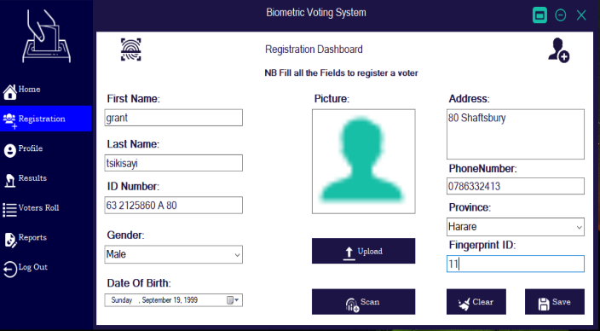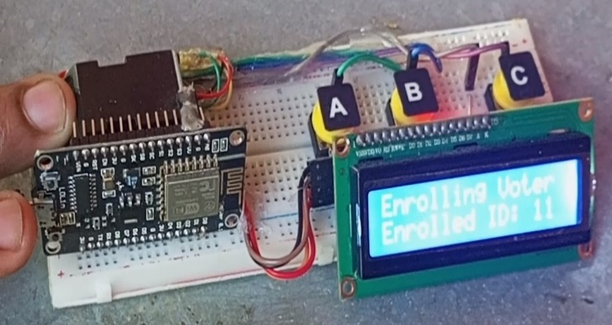

### Successful Voting

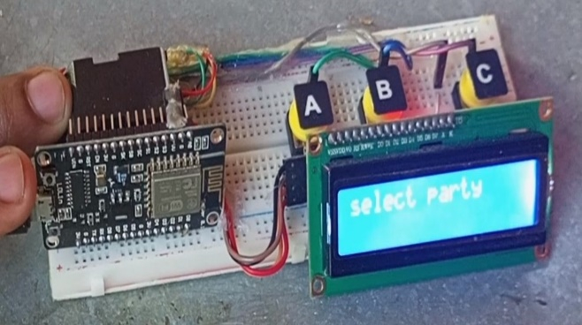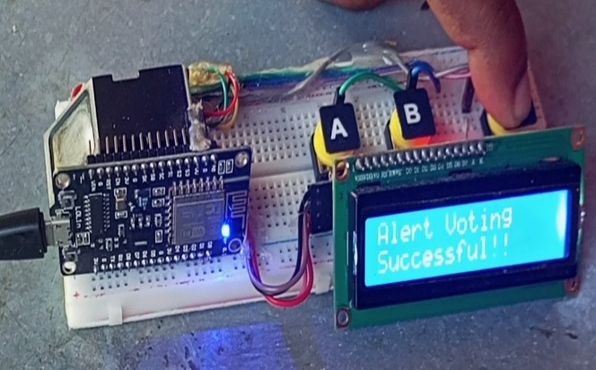

### Validation

#### Invalid ID

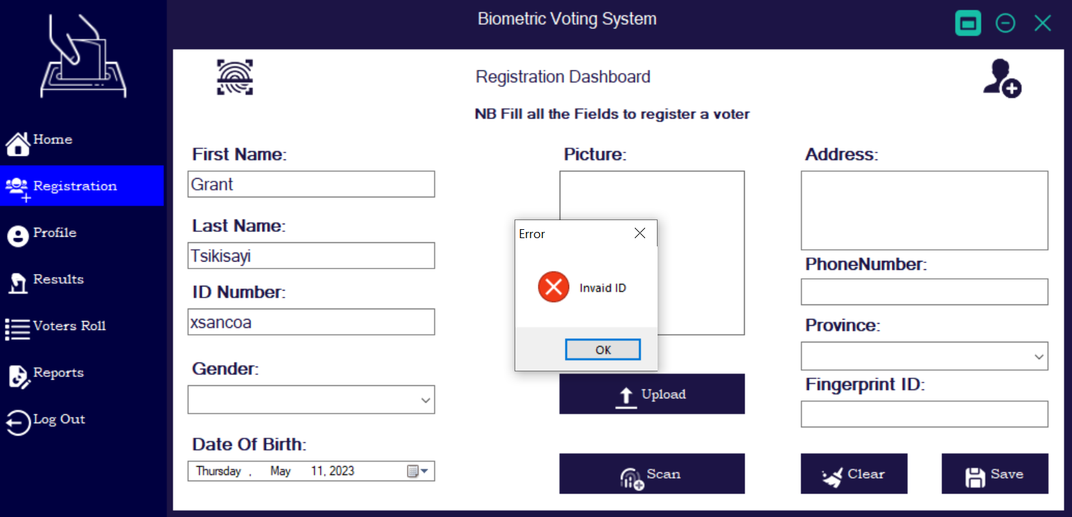

#### Input Wrong Datatype at Keypress

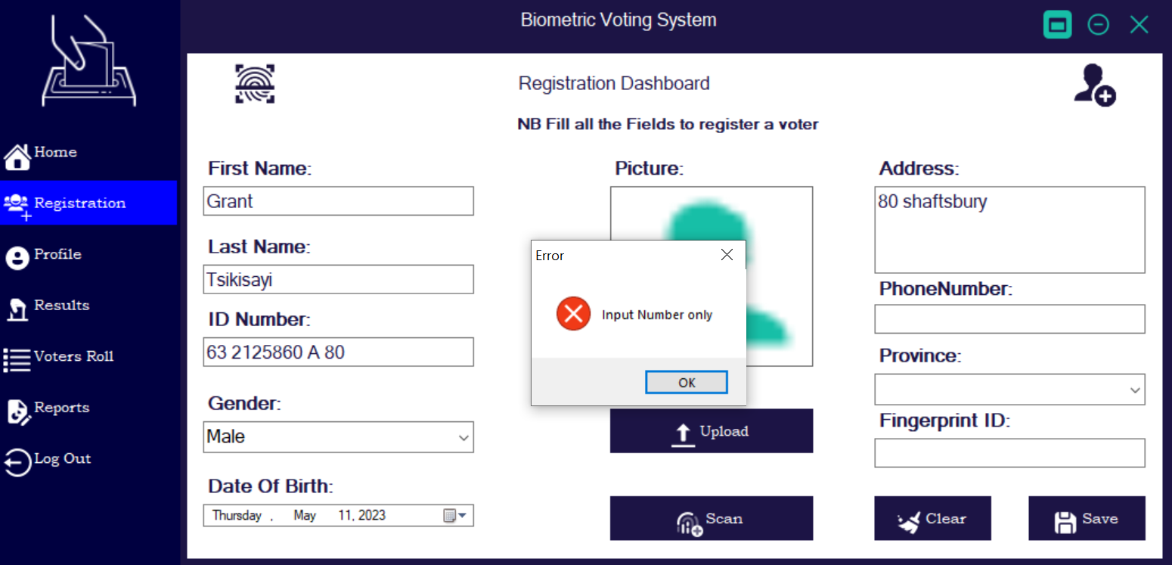

#### Fingerprint Validation

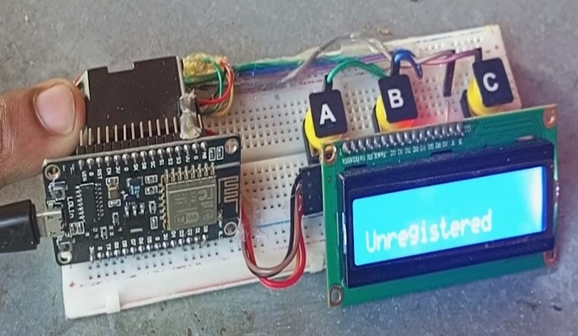 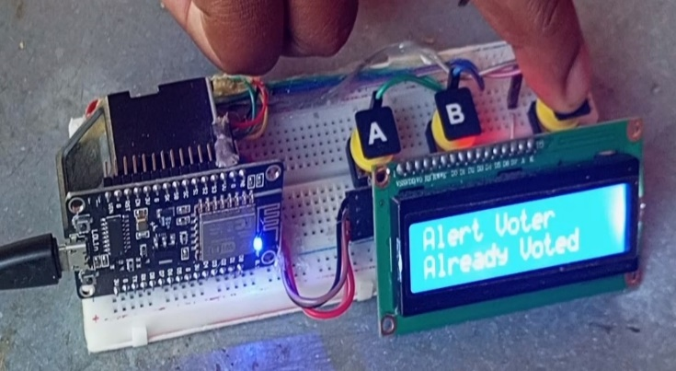

## Summary

**Project Name**: Biometric Voting System

**Project Objective**: To create a biometric voting system that will improve the accuracy and security of the voting process.

**Background Information**: The current voting system is outdated and vulnerable to fraud. A biometric voting system would provide a more secure and accurate way to vote.

**Requirements**: The biometric voting system should be easy to use and accessible to all voters. It should also be secure and tamper-proof to prevent fraud.

**Problems**: The main challenge is developing a system that is both secure and user-friendly. Another challenge is ensuring that the system can handle a large number of voters.

**Analysis:** To address these challenges, we will conduct research on the latest biometric technology and best practices for secure voting systems. We will also work closely with election officials to ensure that the system meets their specific needs.

**Conclusion**: By developing a biometric voting system, we hope to improve the accuracy and security of the voting process. We believe that the new system will be a valuable asset to election officials and help them achieve their goals.

## Reccomendations

* Guaranteeing that the framework is easy to understand and available to all electors, no matter what their specialized aptitude.
* Performing routine security audits to find and fix potential security holes
* Ensuring that election officials and poll workers are able to use the system efficiently by providing them with support and training.
* Making a plan of action in case of technical difficulties or other issues during the voting process.

## Future works

* Improving security and accuracy by using additional biometric authentication methods like facial recognition or iris scanning.
* Creating a mobile application that uses biometric data to enable voters to cast their ballots from a distance.
* Incorporating blockchain technology into the voting system to reduce fraud and improve transparency
* Conducting additional research on biometric voting systems to discover potential security flaws and enhance their effectiveness.
* Taking into account citizen to enroll their fingerprints and utilize any for recognizable proof during casting a ballot.

## Bibliography (References)

1. *V. R. Ch, M. V. P. A and B. S. S. A, "Arduino based Electronic Voting System with Biometric and GSM Features," 2022 4th International Conference on Smart Systems and Inventive Technology (ICSSIT), Tirunelveli, India, 2022, pp. 685-688, doi: 10.1109/ICSSIT53264.2022.9716452.*
2. *(2) I. Goirizelaia, T. Selker, M. Huarte and J. Unzilla, "An Optical Scan E-Voting System based on N-Version Programming," in IEEE Security & Privacy, vol. 6, no. 3, pp. 47-53, May-June 2008, doi: 10.1109/MSP.2008.57.*
3. *A. Joseph, S. George and R. K. Samuel, "A P2P Digital Voting System for Elections in India," 2022 International Conference on Computing, Communication, Security and Intelligent Systems (IC3SIS), Kochi, India, 2022, pp. 1-5, doi: 10.1109/IC3SIS54991.2022.9885353.*
4. *S. Singh, A. Singh, S. Verma and R. K. Dwivedi, "Designing a Blockchain-Enabled Methodology for Secure Online Voting System," 2023 International Conference on Intelligent Data Communication Technologies and Internet of Things (IDCIoT), Bengaluru, India, 2023, pp. 178-184, doi: 10.1109/IDCIoT56793.2023.10053410.*
5. *N. Keerthi, A. Raghuram and R. Jayaraman, "Interfacing of Online and Offline Voting System with an E-Voting Website," 2022 6th International Conference on Devices, Circuits and Systems (ICDCS), Coimbatore, India, 2022, pp. 223-228, doi: 10.1109/ICDCS54290.2022.9780681.*

# Appendices

## Sample code

Hardware code

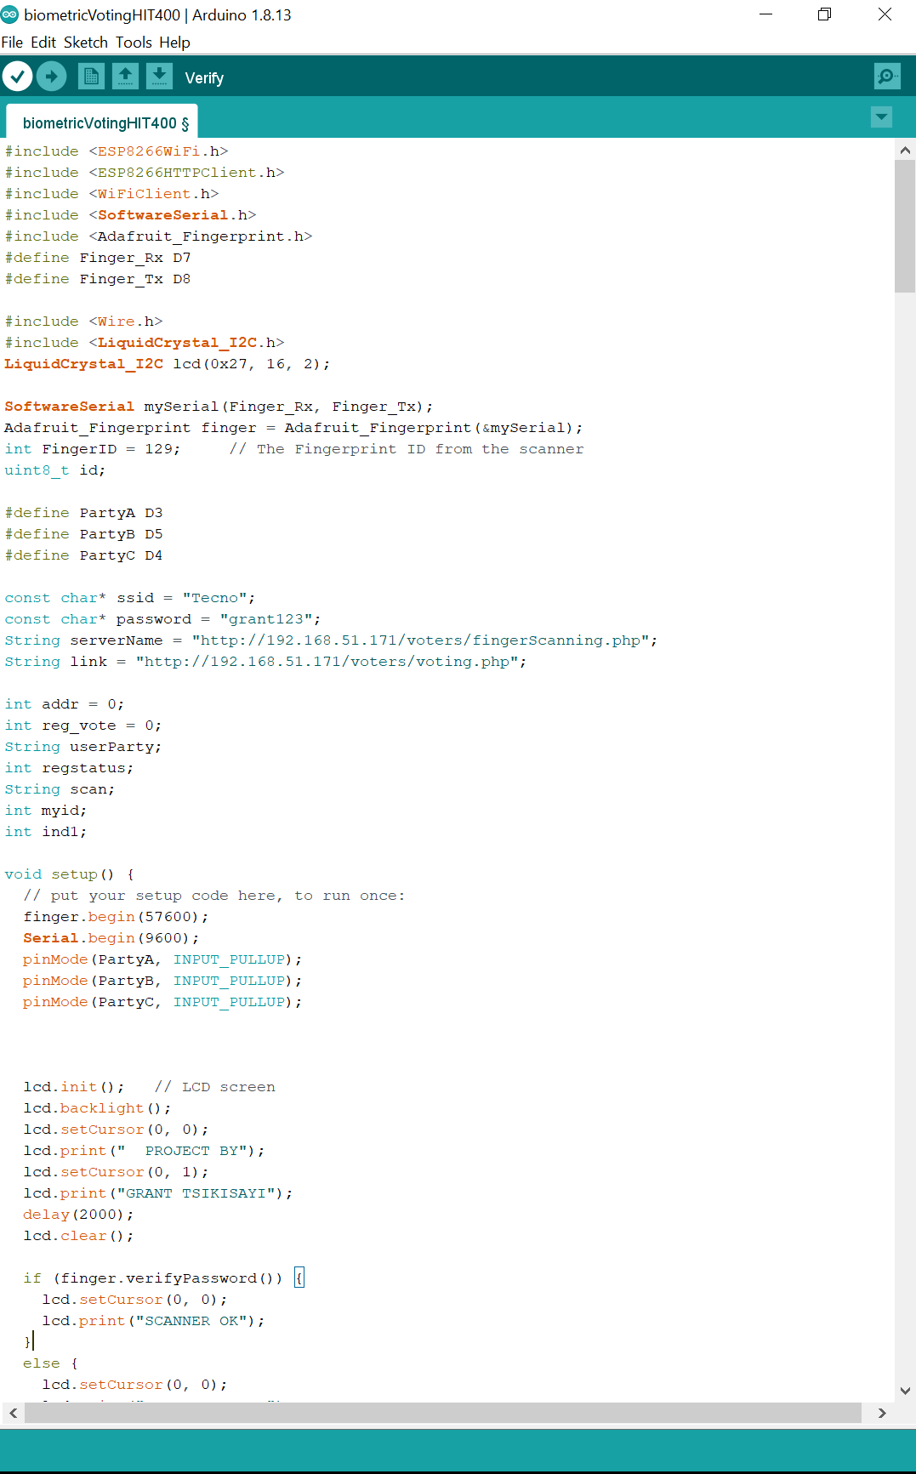

Interface Sample Code

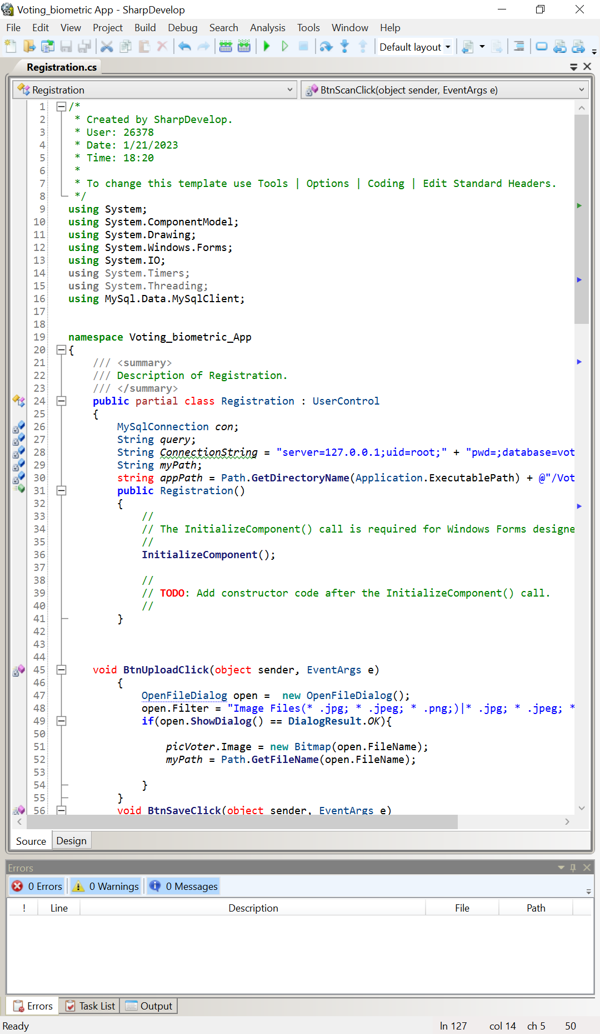

Database Server Sample Code

